INCH-POUND
GL/PD-06-04
5 July 2006

PURCHASE DESCRIPTION

JACKET, WIND COLD WEATHER (GEN III)

1. SCOPE

1.1 Scope. This purchase description covers the requirements for a wind protective jacket, which serves as a layer of the GEN III ECWCS.

1.2 Classification. The jacket shall be of one type in the following sizes, as specified (see 6.2).

SCHEDULE OF SIZES

Size Small Medium Large X-Large

Regular X X X X

Long X X

2. APPLICABLE DOCUMENTS.

2.1 General. The documents listed in this section are specified in sections 3 and 4 of this specification. This section does not include documents cited in other sections of this specification or recommended for additional information or as examples. While every effort has been made to ensure the completeness of this list, document users are cautioned that they must meet all specified requirements cited in sections 3 and 4 of this specification, whether or not they are listed.

2.2 Government Documents.

2.2.1 Specifications, standards, and handbooks. The following specifications, standards, and handbooks form a part of this document to the extent specified herein. Unless otherwise specified, the issues of these documents are those cited in the solicitation or contract.

FEDERAL SPECIFICATIONS

V-T-295 - Thread, Nylon

FEDERAL STANDARDS

FED-STD-4 – Glossary of Fabric Imperfections

COMMERCIAL ITEM DESCRIPTIONS

A-A-55126 - Fastener Tapes, Hook and Loop, Synthetic
AA-A-55634 - Zipper, (Fastener, Slide Interlocking)

DEPARTMENT OF DEFENSE SPECIFICATIONS

MIL-STD-129 – Military Marking for Shipment and Storage
MIL-PRF-5038 - Tape, Textile and Webbing, Textile, Reinforcing Nylon
MIL-DTL-32075 - Label: For Clothing, Equipage, and Tentage, (Gneral Use)

(Copies of these documents are available from the Acquisition Streamlining and Standardization Information System (ASSIST) database, online at http://assist.daps.dla.mil/quicksearch/ or www.dodssp.daps.mil or the Standardization Document Order Desk, 700 Robbins Ave. Philadelphia, PA 19111-9054).

2.2.2 Other Government documents, drawings and publications. The following other Government documents, drawings and publications form a part of this document to the extent specified herein. Unless otherwise specified, the issues are those cited in the solicitation or contract.

U.S. ARMY NATICK SOLDIER CENTER

DRAWINGS

2-1-2519 – Universal Camouflage Pattern

(Copies of drawings are available from the U.S. Army Natick Soldier Center, ATTN: AMSRD-NSC-IP-E, Kansas St., Natick, MA 01760-5019)

CODE OF FEDERAL REGULATIONS

16 CFR Part 1500 – Federal Hazardous Substances Act Regulations
29 CFR Part 1910 – Occupational Safety and Health Standards

(Copies of these documents are available online at: www.access.gpo/nara/cfr or from the Superintendent of Documents, U.S. Government Printing Office, North capitol & “H” Streets, N.W., Washington, DC 20402-0002.)

2.2.3 Non-Government publications. The following documents form a part of this document to the extent specified herein. Unless otherwise specified, the issues of these documents are those cited in the solicitation or contract.

AMERICAN ASSOCIATION OF TEXTILE CHEMISTS AND COLORISTS (AATCC)

AATCC-8 - Colorfastness to Crocking: AATCC Crockmeter Method
AATCC-16 - Colorfastness to Light
AATCC-22 - Water Repellency: Spray Test
AATCC-61 - Colorfastness to Laundering, Home and Commercial: Accelerated
AATCC-70 - Water Repellency: Tumble Jar Dynamic Absorption
AATCC-96 - Dimensional Changes in Commercial Laundering of Woven and Knitted Fabrics, Except Wool
AATCC-135 - Dimensional Changes in Automatic Home Laundering of Woven
and Knitted Fabrics, Except Wool
AATCC – 150 - Dimensional Changes in Automatic Home Laundering of
Garments

(Copies of these documents are available from www.aatcc.org or American Association of Textile Chemists and Colorists (AATCC), P.O. Box 12215, Triangle Park, NC 27709-2215.)

AMERICAN SOCIETY FOR TESTING AND MATERIALS (ASTM)

ASTM D-737 - Air Permeability of Textile Fabrics
ASTM D-747 - Apparent Bending Modulus of Plastics by Means of a
Cantilever Beam
ASTM D-1424 - Tearing Strength of Fabrics by Falling-Pendulum Type
Apparatus
ASTM D-1776 - Practice for Conditioning and Testing Textiles
ASTM D-3776 - Mass Per Unit Area (Weight) of Fabric
ASTM D-5034 - Breaking Strength and Elongation of Textile Fabrics (Grab Test)
ASTM D-6193 - Practice of Stitches and Seams
ASTM E-96 - Water Vapor Transmission of Materials

(Application for copies are available from www.astm.org or American Society for Testing and Materials, 100 Barr Harbor Drive, West Conshohocken, PA 19428-2959.)

AMERICAN NATIONAL STANDARDS INSTITUTE

ANSI/ASQ Z1.4 – Sampling Procedures and Tables for Inspection of Attributes

(For all inquiries, please contact the American National Standards Institute, 25 West 43rd Street, 4th Floor, New York, NY 10036. Website address www.ansi.org)

(Non-Government standards and other publications are normally available from the organizations that prepare or distribute the documents. These documents also may be available in or through libraries or other informational services.)

MISCELLANEOUS

Principle and Methods of Toxicology, A Wallace Hayes (editor), pp 394-396, 1989.

(Copies of this document is available from Raven Press, 1185 Avenue of the Americas, New York, NY 10036)

Marzulli, F. and H. Maibach, “Contact Allergy: Predictive Testing in Humans,”
Advances in Modern Toxicology, Volume 4, pp 353-372, 1977.

(Copies of this document are available from the U.S. Army Center for Health Promotion and Preventative Medicine, ATTN: MCHB-DC-TTE, Bldg., E-2100, Aberdeen Proving Ground, MD 21010-5422.)

2.4 Order of precedence. In the event of a conflict between the text of this document and the references cited herein, the text of this document takes precedence. Nothing in this document, however, supersedes applicable laws and regulations unless a specific exemption has been obtained.

3. REQUIREMENTS

3.1 First article. When specified (see 6.3), a sample shall be subjected to first article inspection (see 4.1).

3.2 Guide samples. Samples, when furnished, are solely for guidance and information to the contractor. Variations from the specification may appear in the sample in which case this specification shall govern.

3.3 Recycled, recovered, or environmentally preferable materials. Recycled, recovered, or environmentally preferable materials should be used to the maximum extent possible provided that the material meets or exceeds the operational and maintenance requirements, and promotes economically advantageous life cycle costs.

3.4 Design. The Wind Jacket shall have a single-breasted front with a slide-fastener (single slider) closure, from the top of the stand-up collar to the bottom of the jacket hem. A protective flap, at the top of the front slide fastener, shall be provided to shield the slide fastener tab. A windbreak protective flap shall be provided which runs from the top of the stand-up collar to the bottom of the jacket hem, on the inside of the left section of the slide fastener. The long sleeves shall have non-adjustable, partially elasticized cuffs. The front shall have two (2) angled chest pockets with protective pockets at the upper end to shield the slide fastener pulls. A piece of loop fastener tape shall be centered between the front closure slide fasteners and the top of both chest pocket slide fasteners, along the seam line. A piece of hook fastener tape shall be centered and sewn above the loop fastener above the left breast pocket. Both sleeves shall have angled bellow pockets with flaps. The sleeve pocket flaps shall have loop fastener tape centered and sewn on the inside of the flap. In addition a loop fastener shall be centered on the flap loop fastener on the pocket side of the flap. A piece of webbing shall be sewn at the center of the outer and inner plies of the flap. A piece of hook fastener shall be sewn on the end of both of the webbing surfaces. A piece of loop fastener and a Identification Friend or Foe tape shall be centered and sewn to the outer surface of the pocket flap. Hook fastener tape shall be centered and sewn on the upper surface of the bellows pocket to mate with the flap loop fastener tape. The hem of the jacket shall be equipped with elastic cord and a barrel lock on each side to allow the jacket skirt to be tightened to prevent wind from entering.

3.5 Basic Materials.

3.5.1 Standard sample. All cloth materials shall match the applicable standard sample for shade and appearance on the face side, and shall be equal to or better than the standard sample with respect to all characteristics for which the standard sample is referenced (see 6.4).

3.5.1.1 Basic shell material. The cloth shall be a plain weave, stretch, nylon and spandex cloth (texture approximating 95 by 60 yarns per inch, warp and filling, respectively), water repellent, meeting the performance requirements of Table I when tested as specified in 4.5. The color of the cloth shall be Universal Camouflage.

* 3.5.1.2 Physical requirements. The cloth shall conform to the physical requirements specified in Table I when tested as specified in 4.5.

TABLE I. Basic Shell Material - Physical Requirements.

Characteristic | Requirement
Weight, oz/sq. yd (max.) | 4.5
Breaking strength, lbs (min.)
Warp | 165
Filling | 130
Stretch and Growth, percent
Stretch (min) | 10
Growth (max) | 5
Tearing Strength, lbs. (min.)
Warp | 6.5
Filling | 4.5
Air Permeability, ft³/ft²/min. (max) | 25.0
Moisture vapor transmission
Rate, g/m²/24h (min.) -
Initial | 800
Stiffness, in-lbs (max.)
At 70ºF | 0.001
At 32ºF | 0.001
Blocking, rating (max.) | No. 2
Water permeability, cm (min) -
Initial | 30
Spray rating, rating (min)
Initial | 100, 100, 90
After 5 launderings | 100, 90, 90
Resistance to organic liquid, pass/fail -
Initial | No wetting
After 5 launderings | No wetting
Dynamic absorption, percent (max.) | 22.0
Dimensional stability, percent (max.)
Warp | 4.0
Filling | 4.0
Color | Universal Camouflage
Pattern Execution | Universal Camouflage Pattern
Spectral Reflectance | Table II
Colorfastness to:  Laundering | Equal to or better than “3-4” rating on AATCC Gray Scale for Color Change
Light | Equal to or better than “3-4” rating on AATCC Gray Scale for Color Change
Crocking | Equal to or better than the standard sample or not less than AATCC chromatic transference scale rating of 3.5
Toxicity | 1/
1/ The finished cloth shall not present a dermal health hazard when used as intended.

3.5.1.3 Color.

3.5.1.3.1 Army Universal Camouflage. The color of the cloth shall be Universal Camouflage pattern and shall match Desert Sand 500, Urban Gray 501, and Foliage Green 502. Each area of the specific color of the pattern shall be in accordance with the applicable standard sample or drawing number 2-1-2519.

3.5.1.4 Pattern execution.

3.5.1.4.1 Army Universal Camouflage pattern execution. The Universal Camouflage pattern shall reproduce the standard sample in respect to design, colors and registration of the respective areas. The pattern repeat of the dyed, printed, and finished cloth shall be 36.00 inches (+1.25 inches, -2.50 inches) in the warp direction. The various areas of the pattern shall be properly registered in relation to each other and shall present definite sharp demarcations with a minimum of feathering or spew. Each pattern area shall show solid coverage; skitteriness exceeding that shown by the standard sample in any of the printed areas shall not be acceptable. When the standard sample is not referenced for pattern execution or design, a pattern drawing shall be provided, and the pattern on the finished cloth shall match that of Drawing 2-1-2519.

3.5.1.5 Spectral reflectance.

3.5.1.5.1 Spectral reflectance, Army Universal Camouflage. The spectral reflectance of the colors in the Universal Camouflage cloth shall conform to the requirements specified in Table II, initially and after laundering when tested as specified in 4.6.8 and 4.6.8.1.

TABLE II. Spectral Reflectance Requirements: Reflectance (percent).

Wavelengths | Desert Sand 500 |  | Urban Gray 501 |  | Foliage Green 502
Nanometers (nm) | Min | Max | Min | Max | Min | Max
600 | 28 | 42 | 12 | 26 | 8 | 18
620 | 30 | 44 | 14 | 26 | 8 | 18
640 | 34 | 50 | 14 | 28 | 8 | 20
660 | 38 | 59 | 14 | 30 | 10 | 26
680 | 44 | 63 | 18 | 34 | 10 | 26
700 | 46 | 69 | 24 | 38 | 12 | 28
720 | 48 | 71 | 26 | 42 | 16 | 30
740 | 48 | 76 | 30 | 46 | 16 | 30
760 | 50 | 80 | 32 | 48 | 18 | 32
780 | 54 | 80 | 34 | 48 | 18 | 34
800 | 54 | 80 | 34 | 50 | 20 | 36
820 | 54 | 80 | 36 | 54 | 22 | 38
840 | 56 | 82 | 38 | 54 | 24 | 40
860 | 56 | 82 | 40 | 56 | 26 | 42

3.5.2 Mesh Tricot pocket lining. Lining fabric shall be Tricot knit mesh of 100% polyester or equal. The color shall be Urban Gray 505. The fabric cloth shall meet the physical requirements specified in Table III when tested as specified in 4.5.

TABLE III. Mesh Pocket Lining - Physical Requirements.

Characteristics | Requirement
Weight (oz./sq yd) | 2.0 + 0.2
Dimensional Stability, percent (max.)
Warp  Filling | 5.0  5.0
Colorfastness:
Laundering | Equal to or better than “3-4” rating on AATCC Gray Scale for Color Change
Crocking | Equal to or better than “3-4” rating on AATCC Gray Scale for Color Change
Light | Equal to or better than the standard sample or not less than AATCC chromatic transference scale rating of 3.5
Toxicity | 1/
1/ The finished cloth shall not present a dermal health hazard when used as intended.

3.6 Components.

* 3.6.1 Thread. The thread for all seaming and stitching shall be V-T-295, “Thread, Nylon” Type I or II, size B, 2-ply at 6.0 pounds breaking strength, with “Water-Repellent” finish.. As an alternate, bobbin/looper threads can be Nylon, size AA, 2-ply, with a minimum breaking strength of 4.0 pounds, with “Water-Repellent “finish. The stitching shall be 9-12 stitches per inch. The color shall be Foliage Green 504.

* 3.6.2 Identification friend or foe material. The material used for the 3/4-inch x 3/4-inch tape shall be Night Vision Equipment Company IFF-55, IR glo-tape; Omniglow Corporation, part number 9-30142, or TVI part number 2B or equal.

* 3.6.3 Webbing/tape. Tape, MIL-PRF-5038, 3/8-inch wide shall be used to construct the slide fastener thong and the retainer for the barrel lock. For the shoulder pocket flap, the tape shall be Type III, Class 2, 1-inch wide by 2 inches long. The color shall be Foliage Green 504.

3.6.4 Tape, hook and loop. The hook and loop fastener tape shall conform to type II, class 1 of A-A-55126, with selvage edges. No slit or split edges are permitted. Sew all hook and loop minimum of 1/8 inch from bound selvage to prevent needle cutting along edges. To prevent raveling, do not sew directly on selvage. However, each required width shall maintain a tolerance of +1/32 inch as to prevent stitching runoffs or improper fit into automatic sewing equipment. The color shall match Foliage Green 504. Chest name tag and rank loop tapes shall be 1 x 5-1/4 in. for chest name loop tapes and 2 x 2-inch for rank tape and attached per pattern placement.

3.6.4.1 Alternate tape, loop. As an alternate, loop fastener tape without selvages edges (reduce field fraying) shall conform to class 1 of A-A-55126 except without selvage edges: YKK “Cosmolon Edge to Edge" with heat-sealed edges or Velcro "DD", an edge-to-edge loop tape. Sew all loop tape minimum of 1/8 inch from edge to prevent needle cutting along edges. However, each required width shall maintain a tolerance of +1/32 inch as to prevent stitching runoffs or improper fit into automatic sewing equipment. The color shall match Foliage Green 504.

3.6.4.2 Alternate tape, hook. As an alternate to hook tape without selvages (reduce field fraying), the following products may be used: Extruded plastic hook tape identified as "Velcro brand HTH 841" or "YKK brand SA200A". The color shall match Foliage Green 504.

3.6.4.3 Colorfastness, tape hook and loop. Unless otherwise specified, for Foliage Green 504, the fastener tapes (hook and loop) shall show fastness to dry cleaning (if required by contract), light (170 Kilojoules), laundering (after 5 cycles) and crocking when tested in paragraph 4.5. The finished tape fasteners shall show fastness equal to or better than a rating “ 4-5 “ to dry cleaning and light, equal to or better than a rating of “2-3” for laundering using AATCC Gray Scale for Color Change and equal to or better that rating of “4” for crocking using AATCC Chromatic Transference Scale. The color depreciation for laundering and light shall remain in the same hue as compared to the original sample. (Hue/cast is defined as the attribute of color that classifies a color as red, blue, green etc.)".

3.6.4.4 Hook and loop laundry durability test method. When tested in accordance with 4.6.17, the hook and loop tapes shall not exhibit fraying edges, peeling yarns, or damage appearance that detracts from the tape appearance or durability.

* 3.6.5 Elastic cord. The elastic cord shall be 1/8-inch width, +1/32-inch, minus 0-inch, elastic cord, 66-inches long, conforming to elongation, 120% +/- 10%; weight per linear yard, 0.2-ounces (max); picks per inch, 60(min); number of carriers, 16; end per carrier, 1; number of elastic strands, 12 (min); cover yarn, polyester. The elastic cord shall have a seared and knotted end. The color shall match Foliage Green 504.

* 3.6.6 Elastic material. The elastic material used on the sleeve cuffs shall be in accordance with MIL-W-5664, Type I, 1/4-inch + 1/32-inch wide.

* 3.6.7 Slide fasteners. The slide fastener for the front closure shall be plastic individual
element, A-A-55634, Type III, Style 8 (left hand separating, single auto-lock slider), No. 5 chain with a 100 pound minimum crosswise strength with water repellent treated slide fastener tape and a 2-1/2 inch, + 1/4 inch thong on long tab pull. The color shall be Foliage Green 504.

* 3.6.7.1 Pocket closure slide fastener. The slide fasteners for the pocket closures shall be plastic, continuous element, A-A-55634, Type I, Style 6 (single no-lock slider), No. 4 chain with a 80 pound minimum crosswise strength with water resistant treated slide fastener tape and a 2-1/2 inch, + 1 inch thong. The color shall be Foliage Green 504. Slider shall close slide fastener chain when pulled up. As an alternate, continuous chain method may be used with ends securely bar-tacked. Slide fastener chain shall be reversed with chain facing inside pockets such that slide fastener tapes faces outward.

3.6.8 Barrel lock. The barrel locks shall maintain a 3-pound minimum holding strength on elastic cord (see 3.6.5) at –40°F, 70°F and 140°F when tested in accordance with 4.6.11. The barrel lock shall be ½ -inch x 3/8-inch elliptical or 3/8-inch round shape, minimum push-button size. The color shall match Foliage Green 504.

3.6.8.1 Cannon clip. The cannon clip used inside the front pockets, shall be Urban Gray 505 and it shall be equal to or better than Part #743-0125 of ITW Nexus, 195 Algonquin Ave., Des Planes, IL 60016.

* 3.6.9 Plastic washer. The plastic washer used inside the pocket to prevent the draw cord from pulling out of the pocket (see 6.6.4).

3.6.10 Interfacing. The interfacing fabric shall be Pellon #933 material or equal.

* 3.6.11 Binding tape. The binding tape shall be a lightweight (approximately 2 ounces per square yard), plain or twill weave polyester or nylon lining bias slit. The color shall be Foliage Green 504. The width shall be such to conceal the slide fastener tape and not impede the slide fastener operation.

3.7 Construction. See Figures 1-5 and patterns for details.

* 3.7.1 Front closure slide fastener. The front closure slide fastener shall be assembled with the pin on the left hand and the slide fastener tape hidden away with binding tape along the slide fastener placket in such a manner to conceal the slide fastener tape and not impede the slide fastener operation. Assemble the slide fastener with a LSq-2 seam type except with the slide fastener inserted between the placket and the main body top stitch. Attach Box side slide fastener tape with top stitch, no placket.

3.7.2 Sleeve bellow pockets. Each sleeve shall have an angled bellows pocket. A single bellow shall be located at the rear of the pocket. The pocket flaps shall have stiffener filler material between the two-ply’s of outer and inner fabric.

3.7.3 Chest pockets assembly. The Tricot knit inside pocket assembly shall be safety stitched together with the outer-shell pocket material with LSbm-3 seam Type with 301 topstitching along the pocket slide fastener assembly.
3.7.4 Self-hem tunnel. The self-hem tunnel shall be seam Type EFag-2 except fold-back ¾-inch with elastic cord placed inside. Hem finish shall be flat with sewn ½-inch buttonhole eyelets at each end of hem where the elastic cord exits the hem. The elastic cord continues through the tunnel housing with buttonhole entry and exit eyelets and onto the lower pocket assembly with buttonhole eyelet for elastic cord button termination. The elastic cord shall be inserted into a plastic washer and a knot will tied into the end of the cord.

3.7.5 Self-hem arm-sleeve wrist. The self-hem arm-sleeve wrist seam shall be seam Type EFag-2 except fold-back ½-inch. The ¼-inch wide elastic shall be placed within the folded-back on the corner sleeve portion of the cuff. Total elastic length shall be 3 inches. The elastic ends shall be bar-tacked at the intersection of the underarm seam and the elastic ends. The finished elastic stretch shall allow a maximum opening of 5-½-inches.

* 3.7.6 Stand-up collar. The jacket shall have a 3-inch high stand-up collar around the entire neck opening. The collar shall be topstitched ¼ inch from edge seam. The collar shall have an interfacing fabric (see 3.6.10).

3.7.7 Labels. Each wind jacket shall have a label in accordance with Type VI, Class 14 of MIL-DTL-32075. The color of the labels shall approximate the ground shade of the basic fabric or white. In addition, it shall contain a bar coding label in accordance with Type VIII and Class 17.

3.7.7.1 The combination size, identification and instruction label for the wind jacket. The combination label shall be sewn on the inside of the jacket along the middle back seam of the collar area. The printed label shall be facing the body. The instruction label shall include the following information:

LAUNDERING (do not dry clean)
a. Home laundering. The garment shall be machine laundered using the delicate/gentile fabric cycle or laundered by hand. Use cold water (up to 90°F/32°C) and cold water laundry detergent (i.e., Liquid Tide of Era Plus). Rinse in clean, cold water. DO NOT STARCH OR BLEACH. Dry in tumble dyer at temperature not exceeding 130°F/54°C as degradation of the component materials will result. Avoid over drying. To drip dry, place on a rust proof hanger. DO NOT PRESS.

b. Field laundering. The garment shall be field laundered using formula II of FM 42-414, Appendix E. DO NOT STARCH OR BLEACH.

3.8 Patterns. Standard patterns, providing a seam allowance of ½ inch for all seams, except where otherwise specified, will be furnished by the Government. The pattern list in Table IV is provided to ensure that the pattern set provided is complete. The Government patterns shall not be altered in any way, and are to be used only as a guide for cutting the contractor’s working patterns. The working patterns will be identical to the Government patterns, except that additional notching to facilitate manufacture is possible. Also, minor modifications are permitted where necessary to accommodate manufacturer’s processes and using automatic equipment. These modifications shall not alter the serviceability or appearance requirements.

* 3.8.1 Pattern parts. The component parts shall be cut from the materials indicated and in accordance with the pattern parts listed in Table IV.

TABLE IV. List of Pattern Parts.

Material | Code | Nomenclature
Mesh Tricot fabric | WNDSHT-INPKT_TOP | Inner Pocket Top
 | WNDSHT-INPKT_BOT | Inner Pocket Bottom
Interfacing fabric | WNDSHT-OUT_CLR_FUS | Outer Collar
 | WNDSHT-ZIPFACE_FUS | Zipper Facing
 | WNDSHT-PKT_FLP_FUS | Pocket Flap
Basic Shell fabric | WNDSHT-BACK | Back
 | WNDSHT-CORD_REIN | Cord Reinforcement
 | WNDSHT-DRAWCORD | Draw Cord
 | WNDSHT-IN_FRT | Inner Front
 | WNDSHT-YOKE | Yoke
 | WNDSHT-IN_CLR | Inner Collar
 | WNDSHT-OUT_CLR | Outer Collar
 | WNDSHT-OUT_PKT | Outer Pocket
 | WNDSHT-PKT_ZIP_FAC | Outer Zipper Facing
 | WNDSHT-SLV | Sleeve
 | WNDSHT-SLV_CORNER | Sleeve Corner
 | WNDSHT-ZIP_FAC | Zipper Facing
 | WNDSHT-PKT_FLAP | Pocket Flap
 | WNDSHT-SLVPKT_BELL | Sleeve pocket bellow

TABLE IV-A. Slide Fastener Lengths (Inches).

Location | Size of Garment
Location | Sm | Med | Lg | XLg | Lg –  Long | XLg –  Long
Front closure | 24-3/4 | 25-3/4 | 26-3/4 | 27-3/4 | 28-1/4 | 29-1/4
Pocket | 11-1/4 | 11-1/4 | 11-1/4 | 11-1/4 | 12-1/4 | 12-1/4

3.9 Stitches, seams, and stitching. All stitches, seams and stitching shall conform to ASTM-D-6193. The type of seam and stitching shall be as specified in Table V. Seam allowances shall be maintained with seams sewn so that no raw edges, run-offs, pleats, puckers or open seams occur.

3.9.1 Type 301 stitching. Ends of all stitching shall be backstitched or overstitched not less than ½ inch except where ends are turned under or caught in other seams or stitching. Ends of a continuous line of stitching shall over-lap not less than ½ inch. Thread tensions shall be maintained so that there will be no loose stitching resulting in loose bobbin or top thread or excessively tight stitching resulting in puckering of the materials sewn. The lock shall be embedded in the materials sewn.

3.9.1.1 Repairs of type 301 stitching.

a. When thread breaks, skipped stitches, run-offs, or bobbin run-outs occur during sewing, the stitching shall be repaired by restarting the stitching a minimum of ½ inch back of the end of the stitching. 1/

b. Except for pre-stitching, thread breaks or two or more consecutive skipped or run-off stitches noted during inspection of the item shall be repaired by overstitching. The stitching shall start a minimum of ½ inch in back of the defective area, continue over the defective area, and continue a minimum of ½ inch beyond the defective area onto the existing stitching. Loose or excessively tight stitching shall be repaired by removing the defective stitching without damaging the materials, and re-stitching in the required manner. 1/

1/ When making the above repairs, the ends of the stitching are not required to be backstitched.

3.9.1.2 Automatic stitching. Automatic machines may be used to perform any of the required stitch patterns provide the requirements for the stitch pattern, stitches per inch, and size and type of thread are met; and at least three tying, overlapping or back stitches are used to secure the ends of the stitching.

3.9.1.3 Thread ends. All thread ends shall be trimmed to a length of not more than ¼ inch unless otherwise specified.

* 3.9.2 Seaming. All seams shall be consistent and exhibit a uniform appearance and conform to the ASTM D 6193 stitch and seam types listed in Table V. The backside of seams (inside garment) shall be flat with no protruding seam allowance. The seams shall be sewn with 9-12 stitches per inch for all outside visible stitching. Topstitch shall be Type 301 lockstitch at 9-12 stitches per inch and ¼ inch gauge. The width of the bight of stitching shall not be less than 1/16-inch. All material edges shall be clean finished, either turned-in, turned-under, or serged.

TABLE V. Seam and Stitching Types.

Seam Placement | Seam Type | Stitch type
Side arms | LSbm-3 | Safety stitch with  301 top stitch
Arm-sleeves | LSbm-3 | Safety stitch with  301 top stitch
Under arms | LSbm-3 | Safety stitch with  301 top stitch
Back horizontal shoulder | LSbm-3 | Safety stitch with  301 top stitch
Upper vertical back | LSbm-3 | Safety stitch with  301 top stitch
Self hem tunnel | Efag-2 | 301 top stitch
Self hem arm-sleeve wrist | LSbm-3 | 301 top stitch
Chest pocket assembly | LSbm-3 | 301 top stitch
Front closure slide fastener | LSq-2 | 301
Note: Construct arm-sleeves and back shoulder seams such that, upper fold-over is on top portion of seam, so water can flow over the seam and not into the seam.

TABLE VI. Bartack Placement.

Bartack Placement 1/ | Number of Bartacks
Arm-sleeve cuff at elastic/underarm seam | 1
Pocket zippers, lower and upper stops | 4
Two sides of pocket top zipper slider housing | 4
Front closure zipper top and bottom tape | 4
1/ All reinforcement bartacks shall use Nylon size B thread with Water Repellent Treatment.
Bartack length is ½ inch with 28 stitches.

4. VERIFICATION

  - Classification of inspections. The inspection requirements specified herein are
classified as follows:

a. First article inspection (see 4.2).
b. Conformance inspection (see 4.3).

4.2 First article inspection. When a first article is required (see 3.1 and 6.3), it shall be examined for the defects specified in 4.6.15 and tested as specified in 4.4.1, 4.6.16 and 4.5.

4.3 Conformance inspection. Sampling for inspection shall be performed in accordance with ANSI/ASQC Z1.4, as defined by contract, except where otherwise specified.

4.4 Component and end item inspections. In accordance with 4.1, components and materials in the end items shall be tested in accordance with all the requirements of referenced documents unless otherwise excluded, amended, modified or qualified in this document or applicable procurement documents. The government reserves the right to inspect all components and end items to determine conformance to requirements.

4.4.1 Component and material certification. Unless otherwise specified, a certificate of compliance will be acceptable as evidence that the requirements of 3.5 and 3.6 are met. When certificate of compliance are submitted, the Government reserves the right to inspect such items to determine the validity of the certification.

4.5 Basic material testing. The basic material specified in 3.5 through 3.5.2 shall be tested for the characteristics listed in Table VII in accordance with the test method cited.

TABLE VII. Basic Material Testing.

Characteristic | Reference Paragraph | Test method

Basic shell material
Fiber identification, weave and fabric count |  | 1/
Weight | 3.5.1.2 | ASTM D-3776 (Method C)
Breaking strength | 3.5.1.2 | ASTM D-5034 (G-E or G-T)
Elongation | 3.5.1.2 | ASTM D-5034 (G-E or G-T)
Tearing Strength | 3.5.1.2 | ASTM D-1424
Air Permeability | 3.5.1.2 | ASTM D-737
Moisture vapor transmission | 3.5.1.2 | 4.6.1
Stiffness
At 70ºF | 3.5.1.2 | ASTM D-747 3/
At 32ºF | 3.5.1.2 | 2/ & ASTM D-747 3/
Blocking | 3.5.1.2 | 4.6.2
Water permeability
Initial | 3.5.1.2 | 4.6.3
Spray rating
Initial | 3.5.1.2 | 4.6.4.1
After 5 launderings | 3.5.1.2 | 4.6.4.2 & 4.6.4.1
Resistance to organic liquid
Initial | 3.5.1.2 | 4.6.5.1
After 5 launderings | 3.5.1.2 | 4.6.5.2
Dynamic absorption | 3.5.1.2 | AATCC-70
Dimensional stability | 3.5.1.2 | AATCC-96, Option 1C
Color | 3.5.1.2 | 4.6.6
Pattern Execution | 3.5.1.2 | 4.6.7
Spectral Reflectance | Table II | 4.6.8 & 4.6.8.1
Colorfastness to:  Laundering | 3.5.1.2 | 4.6.9.1
Light | 3.5.1.2 | 4.6.9.1.2
Crocking | 3.5.1.2 | AATCC-8
Toxicity | 3.5.1.2 | 4.6.14
Mesh Tricot pocket lining
Fiber identification and weave |  | 1/
Weight | 3.5.2 | ASTM D-3776 (Method C)
Dimensional Stability | 3.5.2 | AATCC – 135, IIIA
Colorfastness:
Laundering | 3.5.2 | AATCC-61, IIA
Crocking | 3.5.2 | AATCC-8
Light | 3.5.2 | 4.6.9.1.2
Toxicity | 3.5.2 | 4.6.14

Elastic cord
Elongation | 3.6.5 | 4.6.12
Weight | 3.6.5 | ASTM D- 3776
Picks/inch | 3.6.5 | Visual
Number of carriers | 3.6.5 | Visual
Ends per carrier | 3.6.5 | Visual
Elastic strands/width | 3.6.5 | 4.6.13
Fastener Tape, Hook and Loop
Color | 3.6.4 | 4.6.13
Colorfastness To:
Dry cleaning | 3.6.4.3 | AATCC -132
Light | 3.6.4.3 | 4.6.9.1.2
Laundering after 5 cycles | 3.6.4.3 | AATCC – 61, Opt. 3A
Crocking | 3.6.4.3 | AATCC - 8
Laundry Durability | 3.6.4.4 | 4.6.17-4.6.17.4
1/ A certificate of compliance shall be submitted for these requirements.
2/ The test specimens and testing machine shall be exposed to 32°F +/- 2°F for 4 hours.
The test shall then be performed in still air at that temperature.
3/ Stiffness (bending moment) shall be conducted in accordance with ASTM D-747 except as follows:

a. Unless otherwise specified, the testing conditions shall be in accordance with ASTM D-1776.
b. The test specimen shall be a rectangle of cloth of dimensions two (2) by one (1) inches with the long dimension parallel to the fabric direction under test, warp or filling, as applicable.
c. The load scale reading shall be recorded only at the specimen angular deflection of 60 degrees.
d. The stiffness is the bending moment of specimen at a deflection angle of 60 degrees and shall be calculated to three significant figures as follows:

Bending moment, in.-lb. = Load scale reading x moment weight*
100

* Testing machine of Tinius Olsen Testing Machine Co.

4.6 Methods of testing. All testing shall be done in a standard condition environment defined by the ASTM D-1776, if not specifically defined by the individual test procedure.

4.6.1 Moisture vapor transmission rate. ASTM E-96 with temperature and humidity conditions of 73.5º + 1ºF and 50 + 2% R.H. The linear air flow velocity in the wind tunnel shall be set to yield an upright, ‘open cup’ evaporation rate at all test specimen positions of 15,000 + 1,000 g/m²/24hrs, (the evaporation rate shall be determined by conducting an upright cup, Procedure B test without a test specimen for a period of exactly two (2) hours).

4.6.1.1 Procedure B. ASTM E-96. The back side of the basic material shall face the water. The test specimen shall be conditioned, after set-up in the test cup with water level of 3/4 + 1/16 inch below the specimen surface, in the wind tunnel for a period of not less than four (4) hours and not more than sixteen (16) hours Conditioning time of less than 4 hours may be used provided that equilibrium conditions have been demonstrated to exist within the test sample/sample cup/wind tunnel. (In cases of dispute, the conditioning time shall be 4 hours.). After conditioning, the cup shall be immediately weighed to start the test and again after exactly twenty-four (24) hours to complete the test. Five (5) specimens shall be tested.

4.6.2 Blocking. Blocking Resistance at Elevated Temperatures, except that the tests shall be performed at a temperature of 180ºF + 2ºF for 30 minutes. Only one (1) specimen shall be tested. Evaluate the resistance of the specimen to blocking by the scale given below:

1 -- No Blocking. Cloth surfaces are free and separate without any evidence
of cohesion or adhesion.
2 -- Trace Blocking. Cloth surfaces show slight cohesion or adhesion.
3. -- Slight Blocking. Cloth surfaces must be lightly peeled to separate.
4 -- Blocking. Cloth surfaces separate with difficulty or coating is removed during
separation.

4.6.3 Water permeability. ASTM D-751, Hydrostatic Resistance, Procedure B, Procedure 1 with a rising hydrostatic head at 10 mm/sec applied to the face side of the test specimen. Five (5) specimens shall be tested. Leakage is defined as the appearance of one (1) or more droplets of water within the 4-1/2 inch diameter test area.

4.6.4 Spray rating.

4.6.4.1 Initial. Testing shall be conducted in accordance with AATCC-22.

4.6.4.2 After 5 launderings. Test specimens shall be laundered for five (5) laundering cycles in accordance with 4.6.9.1.1 and then tested for spray rating in accordance with 4.6.4.1.

4.6.5 Resistance to organic liquids.

4.6.5.1 Initial. Place a small specimen of the cloth on a smooth horizontal surface, face side up. Using a pipette or eyedropper, gently deposit one (1) drop of n-tetradecane on the surface of the specimen. After 30 seconds, examine the specimen under light at an angle. Absence of light reflectance at the cloth/drop interface shall be taken as evidence of wetting. Three (3) specimens (or areas) taken at various locations across the sample unit shall be tested. Evidence of wetting on one (1) or more specimens shall be considered a test failure.

4.6.5.2 After 5 launderings. Test specimens shall be laundered for five (5) laundering cycles in accordance with 4.6.9.1.1 and then tested for resistance to organic liquids in accordance with 4.6.5.1.

4.6.6 Color matching. The color and appearance of the cloth shall match the standard sample when viewed using the AATCC Evaluation Procedure 9, Option A, with sources simulating artificial daylight and that have a correlated color temperature of 7,500º + 200ºK, with illumination of 100 + 20 foot candles, and shall be a good match to the standard sample under incandescent lamplight at 2,300º + 200ºK.

4.6.7 Pattern execution. The pattern of the cloth shall be matched to the pattern, Drawing No. 2-1-2519.

4.6.8 Spectral reflectance. Spectral reflectance data shall be determined on the face side and shall be obtained from 600 to 860 nanometers (nm) at 20 nm intervals on a spectrophotometer, relative to the barium sulfate standard, the preferred white standard. Other white reference materials may be used provided they are calibrated to absolute white, e.g., magnesium oxide or vitolite tiles. The spectral band width shall be less than 26 nm at 860 nm. Reflectance measurements may be made by either the monochromatic or polychromatic mode of operation. When the polychromatic mode is used, the spectrophotometer shall operate with the specimen diffusely illuminated with the full emission of a source that simulates either CIE source A or CIE source D65. The specimen shall be measured as a single layer, backed with six layers of the same fabric and shade. Measurements shall be taken on a minimum of two (2) different areas and the data averaged. The measured areas should be at least 6 inches away from the selvage. The specimen shall be viewed at an angle no greater than 10 degrees from the normal, with the spectral component included. Photometric accuracy of the spectrophotometer shall be within 1 percent and wavelength accuracy within 2 nm. The standard aperture size used in the color measurement device shall be 1.0 to 1.25 inches in diameter. Any color having spectral reflectance values falling outside the limits at four or more of the wavelengths specified shall be considered a test failure.

4.6.8.1 Accelerated laundering (Spectral Reflectance Durability Test). The cloth shall be laundered separately in accordance with AATCC-61 (Option 3A) except that a 4-gram sample size shall be used (Note: A sample size large enough to evaluate the spectral reflectance shall be used) and that the procedure shall be conducted using (10) stainless steel spheres and the 1993 AATCC Standard Reference Detergent without optical brightener. The samples shall then be evaluated for spectral reflectance in accordance with 4.6.8.

4.6.9 Colorfastness.

4.6.9.1 Laundering. AATCC-61, Test 1A (3 cycles) except that 1993 AATCC Standard Reference Detergent (non-phosphate) without optical brighteners shall be used.

4.6.9.1.1 Laundering procedure. Place 2.0 + 0.2 pounds of the cloth and, if needed, ballast in an automatic washing machine set on permanent press cycle, high water level and warm (100°F + 10°F, -0°F) wash temperature. Place 0.5 ounce (14 grams) of 1993 AATCC Standard Reference Detergent (non-phosphate) without optical brighteners into the washer. The duration of each laundering cycle shall be 30 + 5 minutes. After laundering, place sample and ballast in an automatic tumble dryer set on permanent press cycle, 150°F - 160°F, and dry for approximately fifteen (15) minutes. The laundering equipment, washer and dryer, shall be in accordance with AATCC-135.

4.6.9.1.2 Light. AATCC-16, Option A (after 40 fading units) or E (after 170 kilojoules).

4.6.10 Stiffness. Stiffness at 70ºF and 32ºF.

4.6.11 Barrel lock test. The barrel lock holding strength shall be tested as follows:

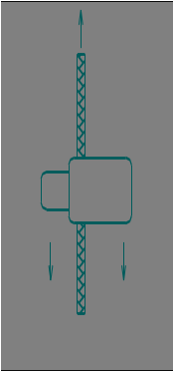
Barrel lock holding strength: Using tensile testing machine in accordance with ASTM D 5034, at 2 inches/minute either pull-up cord on stationary engaged barrel lock or vice-versa.

4.6.12 Elongation. Cut a 14-inch specimen from a representative sample cord and make two marks on the cord so that a distance of 10 inches is between the gage marks. Suspend the cord from a clamp in such a manner as to allow a 2-pound weight to be hung on the lower end of the cord. Gradually lower the weight until the entire load is carried by the cord. After 2 minutes, take a measurement between the two marks and calculate the increase in length as follows:

Elongation (%) = B-A x 100
A

Where:
A = Initial measurement
B = Measurement of elongation at 2 pounds

4.6.13 Gage of rubber. The gage of rubber (elastic strands) shall be determined by counting the actual number of strands, laid side by side, contained in 1 inch. The gage is equivalent to the actual number of rubber yarns contained in 1 inch. A measuring device that measures the gage of rubber yarns may be utilized providing results are comparable.

4.6.14 Toxicity assessment. The contractor must furnish information, which certifies that the finished product is composed of materials, which have been safely used commercially or provided sufficient toxicity data to show compatibility with prolonged, direct skin contact. At a minimum, toxicity data should include results from a primary dermal irritation study in laboratory animals and a repeated insult human patch test (Modified Draize Procedure). The latter must be conducted under the supervision of a qualified dermatologist using at least 100 free-living individuals.

4.6.14.1 Toxicity documents. All finishes/chemicals used to process the garment shall be identified and accompanied by the appropriate Material Safety Data Sheet (MSDS) information. The use of chemicals recognized by the Environmental Protection Agency (EPD) as human carcinogens is prohibited.

4.6.15 End item visual examination Jackets shall be subjected to a visual examination for defects. All garment defects shall be scored in accordance with Table VIII.A. Material defects are defined in Section I of FED-STD-4 and table VIII. All shade evaluation of the garment shall be evaluated at a distance of 3 feet and under the artificial daylight as specified in 4.6.6.

Table VIII. Material Visual Examination

Examination | Defect
Cloth | Hole, cut, tear, smash, burn, exposed drill hole, run, thin place,  Dye streak, color not as specified, misweave visible mends.  Knots greater than Sears Scale Level C (See 6.5)  Slubs greater than Sears Scale Level D (See 6.5)
Skitteriness | Pattern design not equal to standard sample; Excessive feathering or spew of pattern; Pattern repeat not equal to the standard sample; Army Universal Camouflage pattern less than 33-1/2 inches or more than 37-1/4 inches.

* TABLE VIII.A. Jacket Visual Examination

Examination | Defect
Component Part | Component part of jacket omitted, not as specified, distorted, full, tight, or twisted; any part of jacket in unrelated stitching, the edge of any component part required to be forced out having folds of more than 1/8 inch
 | Fullness creating unwanted permanent fold, pleat, or crease in fabric or garment
Stitching and Seams | Jacket seam: open stitching, puckered, distorted, pleated, wavy, twisted, irregular, or loose or tight stitch tension, broken or missing thread or stitch, needle chew, edge or raise stitching sewn too close to the edge resulting in damage to cloth, seam allowance not as specified, no visible raw edge (more than one occurrence of inside raw edge greater than 1 inch)
 | Stitching not as specified
 | Double needle intersecting seams staggered by more than 1/4 inch
 | Run off of more than ½ inch for edge and raised stitching
 | Thread color not as specified
Evenness | Length of jacket fronts uneven by more than 1/4 inch at top or bottom when closed  Collar curls, puckers, pleats, or twists  Sleeve lengths vary by more than 1/2 inch Hem by more than 1/8 inch.
Hook & Loop | Hook & loop misplaced, damaged or omitted, twist or distortion when closed, out of alignment causing bulge  Hook & loop out of alignment by more than 1/4 inch  Hook & loop color or type not as specified
Hems | Hem of jacket bottom less than 3/4- inch or more than 1-inch  Ends of hem not sewn closed, twisted puckered, pleated, wavy, distorted
Slide Fastener | Not specified length, not specified type
Twisted, distorted, damaged, puckered, color not as specified
Thong omitted, not as specified
Not located in correct position on jacket front
Pocket and Flaps | Pocket companions not uniform in size or shape  Pockets twisted, curled or puckered, not stitched as specified  Pocket flaps not completely covering pocket opening, not positioned as specified  Pocket construction not as specified  Pockets out of alignment 1/4 inch or more  Bellows exposed
Eyelets | Omitted, misplaced, improper size or caught in stitching. Stitch type not as specified
Shade | Shade variation within part or between parts
Cleanness | Spot stain, excessive thread ends no more than 1/4inch (more than 3) not trimmed or removed, odor, affecting appearance or serviceability
Bartack | Omitted, misplaced, loose stitching, not specified size, not serving intended purpose.
Labels | Any label omitted, incorrect, illegible, not attached where specified
Packaging | Any jacket not packaged in accordance with contract or purchase order

* 4.6.16 Finished measurements. The jacket finished measurements shall be in accordance with table IX.

TABLE IX. Jacket Finished Measurements (Inches)

Description | Tolerance | Small  Reg | Medium  Reg | Large Reg | Large  Long | XLarge  Reg | XLarge  Long
Chest | -1/2, +1 | TBD | 51 ½ | TBD | TBD | TBD | TBD
Sweep | -1/4, +1/2 | TBD | 45 | TBD | TBD | TBD | TBD
Back Length | -1/4, +1/2 | TBD | 29 | TBD | TBD | TBD | TBD
Sleeve Inseam | -1/4, +1/2 | TBD | 25 ¾ | TBD | TBD | TBD | TBD
Sleeve Outseam | -1/4, +1/2 | TBD | 23 ½ | TBD | TBD | TBD | TBD
Sleeve Underarm Width | -1/4, +1/2 | TBD | 10 ½ | TBD | TBD | TBD | TBD
Collar Height @ CB | -1/4, +1/2 | TBD | 3 | TBD | TBD | TBD | TBD
Collar Height @ CF | -1/4, +1/2 | TBD | 2 ½ | TBD | TBD | TBD | TBD

Description | Measurement
Chest | Twice the measurement taken across front from folded edge to folded edge at base of armhole.
Sweep | Twice the measurement taken along bottom edge of jacket from folded edge to folded edge.
Back Length | Measurement taken from seam at center back to bottom of jacket along center of back.
Sleeve Inseam | Measurement taken along underarm seam from base of armhole to bottom edge of sleeve.
Sleeve Outseam | Measurement taken along folded edge opposite underarm seam of sleeve from neckline seam to bottom edge of sleeve.
Sleeve Underarm Width | Twice the measurement taken from the underarm seam to a point perpendicular to the folded edge.
Collar Height @ CB | Measurement taken from center back neck seam to top of collar.
Collar Height @ CF | Measurement taken from neckline seam adjacent to the slide fastener to the top of collar.

4.6.17 Hook and loop laundering durability test method procedures. The hook and loop tape shall meet the requirements stated in 3.6.4.4 when tested for laundry durability. Use test replica or garment test sample method to verify laundry durability.

4.6.17.1. Test Replica Sample Preparation: Fabricate two test replica samples from basic material paragraph 3.5.1.1. One test replica sample shall contain hook tape on the outer surface and the other test replica sample shall contain loop tape on the outer surface. Finished dimensions of each test replica sample shall be 20-inches by 20-inches. The hook and loop tape, paragraphs 3.6.4-3.6.4.2, sewn to the test sample shall represent production widths, lengths and quantities used in jacket fabrication. Evenly distribute hook and loop tape pieces on both sides of each test replica sample. Sewn hook and loop pieces with box stitch 1/8-inch to 3/16-inch from selvage using 301 stitch type. Insert fabric squares into test replica sample to achieve 1.4 pound minimum weight per test sample. Close test replica sample and stitch around entire sample to prevent curling and balling up of internal fabric squares.

4.6.17.2 Alternate Garment Test Sample. As an alternate, used two (2) wind jackets sewn with representative hook and loop tapes used in production shall be laundered as a set. To assess worse case situation of hook and loop failure during laundry test, do not engage hook and loop tapes or slide fastener (zipper).

4.6.17.3 Wash Procedures for Test Replica Samples or Alternate Garment Test Samples. Launder two test replica samples, one hook sample and one loop sample, or two wind jackets with test method AATCC-150 which includes sample and ballast load weighing a total of 4-pounds. Note: For Garment Sample – do not engage hook and loop tapes to represent worse case situation. Wash setting shall be Permanent Press, 140°F wash and 80°F rinse with a 10 minute agitation time. Use 66 grams of detergent conforming to 1993 AATCC detergent without bleach for each laundering. Drying time shall be Permanent Press for 40-45 minutes.

4.6.17.4 Number of Laundering/Drying Cycles. A total of 15 laundering and drying cycles for each test replica sample set or wind jackets.

5. PACKAGING

  - Packaging. For acquisition purposes, the packaging requirements shall be as specified in the contract or order (see 6.2). When packaging of materiel is to be performed by DoD or in-house contractor personnel, these personnel need to contact the responsible packaging activity to ascertain packaging requirements. Packaging requirements are maintained by the Inventory Control Point’s packaging activities within the Military Service or Defense Agency, or within the military service’s system commands. Packaging data retrieval is available from the managing Military Department’s or Defense Agency’s automated packaging files, CD-ROM products, or by contacting the responsible packaging activity.

6. NOTES

(This section contains information of a general or explanatory nature that may be helpful, but is not mandatory).

6.1 Intended use. The ECWCS, GEN III, Wind Jacket is for wear by soldiers, as a separate wind resistant outer garment, or as a part/layer of multi-component Extreme Cold Weather Clothing System. The principle purpose is to provide protection against the adverse effects of cold wind.

6.2 Acquisition requirements. Acquisition documents must specify the following:

a. Title, number and date of this specification.
b. Size required (see 1.2)
c. When a first article is required (see 3.1, 4.2, and 6.3)
d. Packaging (see 5.1)

6.3 First Article. When a first article is required, it shall be inspected and approved under the appropriate provision of FAR 52.209. First article should be a preproduction sample. The contracting officer should specify the appropriate type of first article and the number of units to be furnished. The contracting officer should also include specific instructions in acquisition documents regarding arrangements for selection, inspection, and approval of the first article.

6.4 Standard shade samples. For access to standard samples, address the contracting activity issuing the invitation for bids or request for proposal.

6.5 Fabric defects scales. Fabric Defect Replica Kits are available from Sears, Roebuck and Company, Department 817HG, FC568B, 3333 Beverly Road, Hoffman Estates, IL 60179.

* 6.6 Possible material sources.

6.6.1 Cannon clip.

ITW Nexus

6.6.2 Tape, hook and loop.

Velcro USA, Inc
or
YKK Corporation of America

6.6.3 Identification, friend or foe material.

Night Vision Equipment Company
or
Omniglow Corporation
or
TVI Corporation

6.6.4 Plastic washer. A polyolefin washer approximating 9/16-inch diameter and 30 mils thick has been shown to work for this application.

6.6.5 Interfacing fabric.

Freudenberg Nonwovens, LTD

6.7 Subject terms (key word) list.

Jacket
ECWCS
Cold weather Clothing
Extended Cold Weather Clothing System
Wind protection

6.8. Asterisk (*) denotes change/update has been made to the paragraph compared to previous revision.

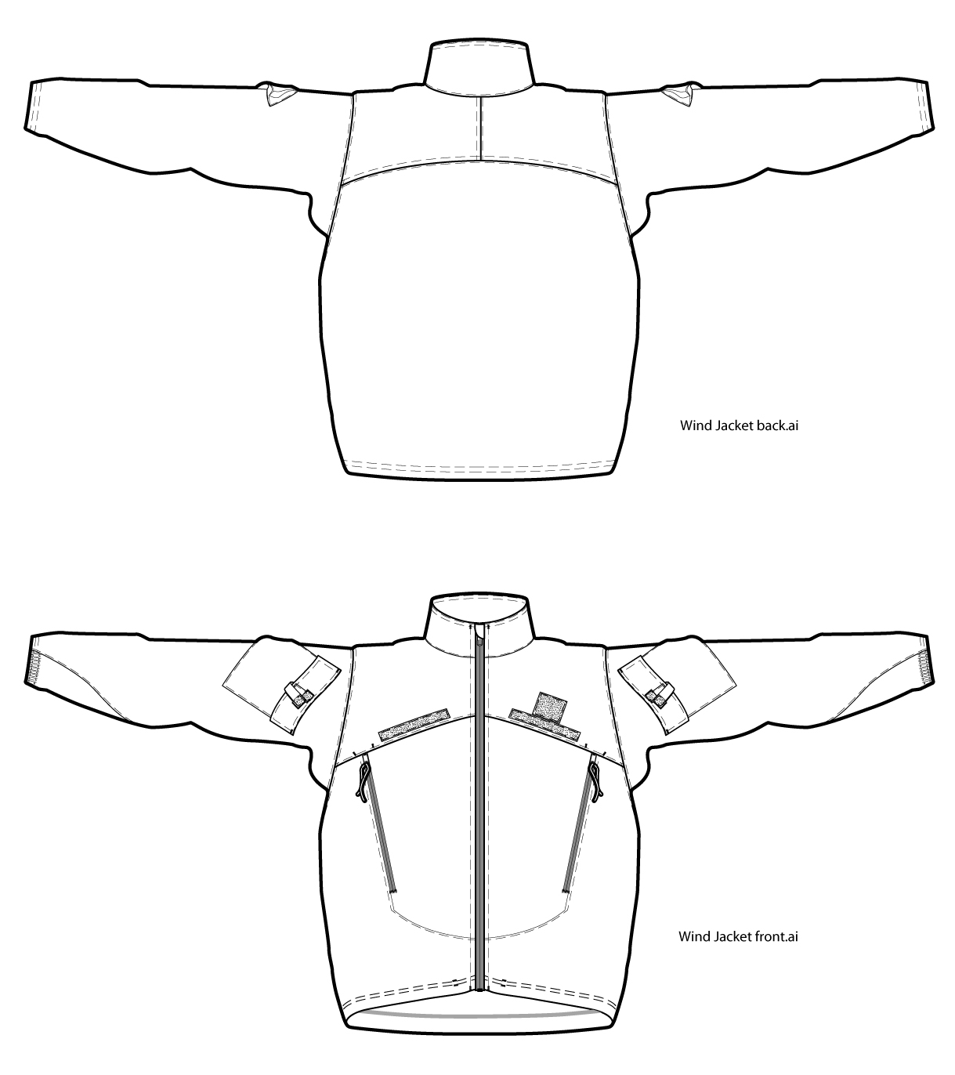
Figure 1

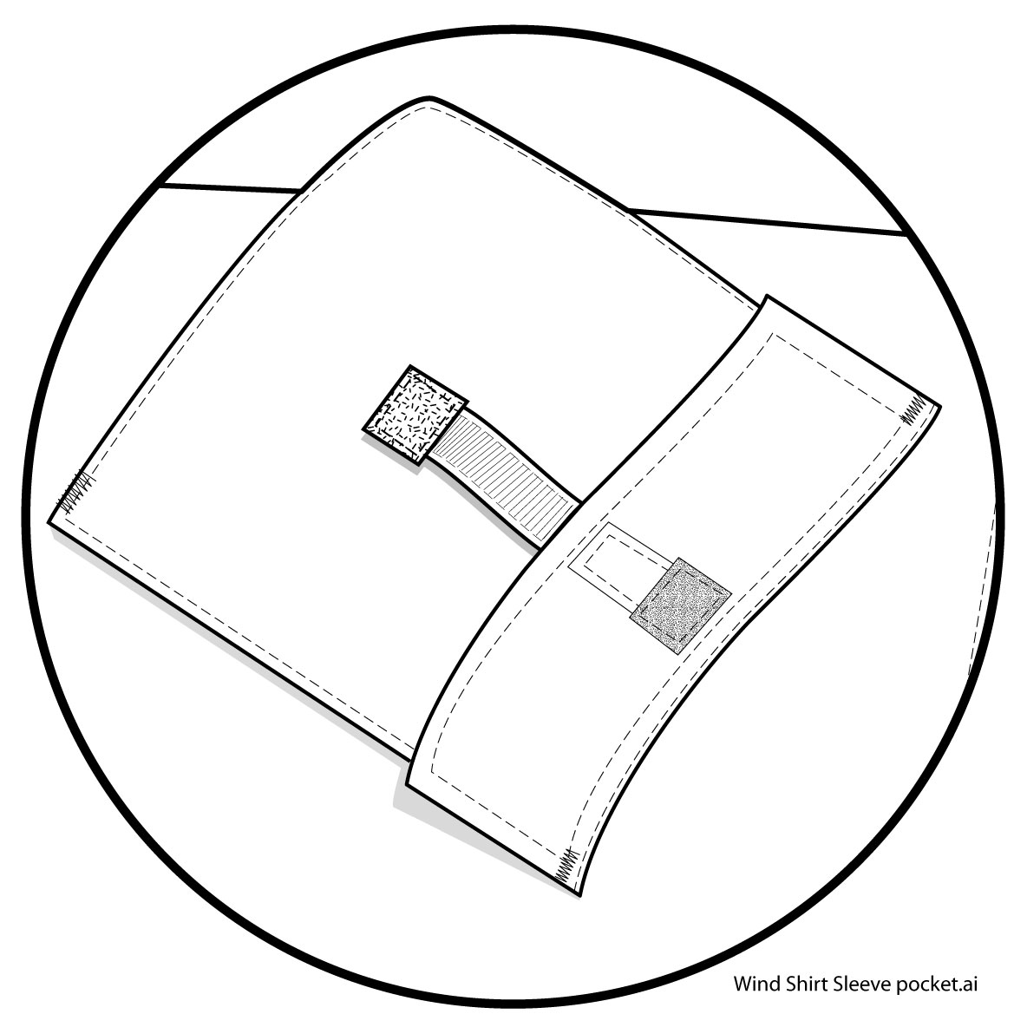
Figure 2
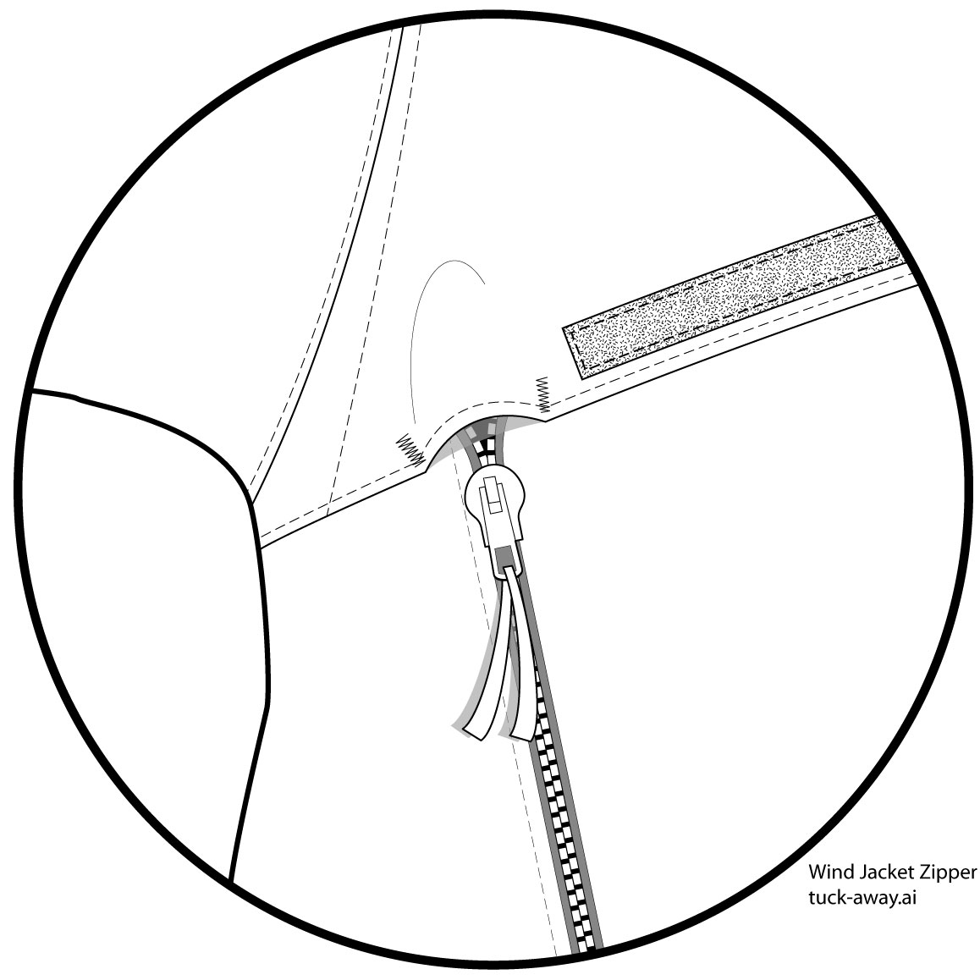
Figure 3
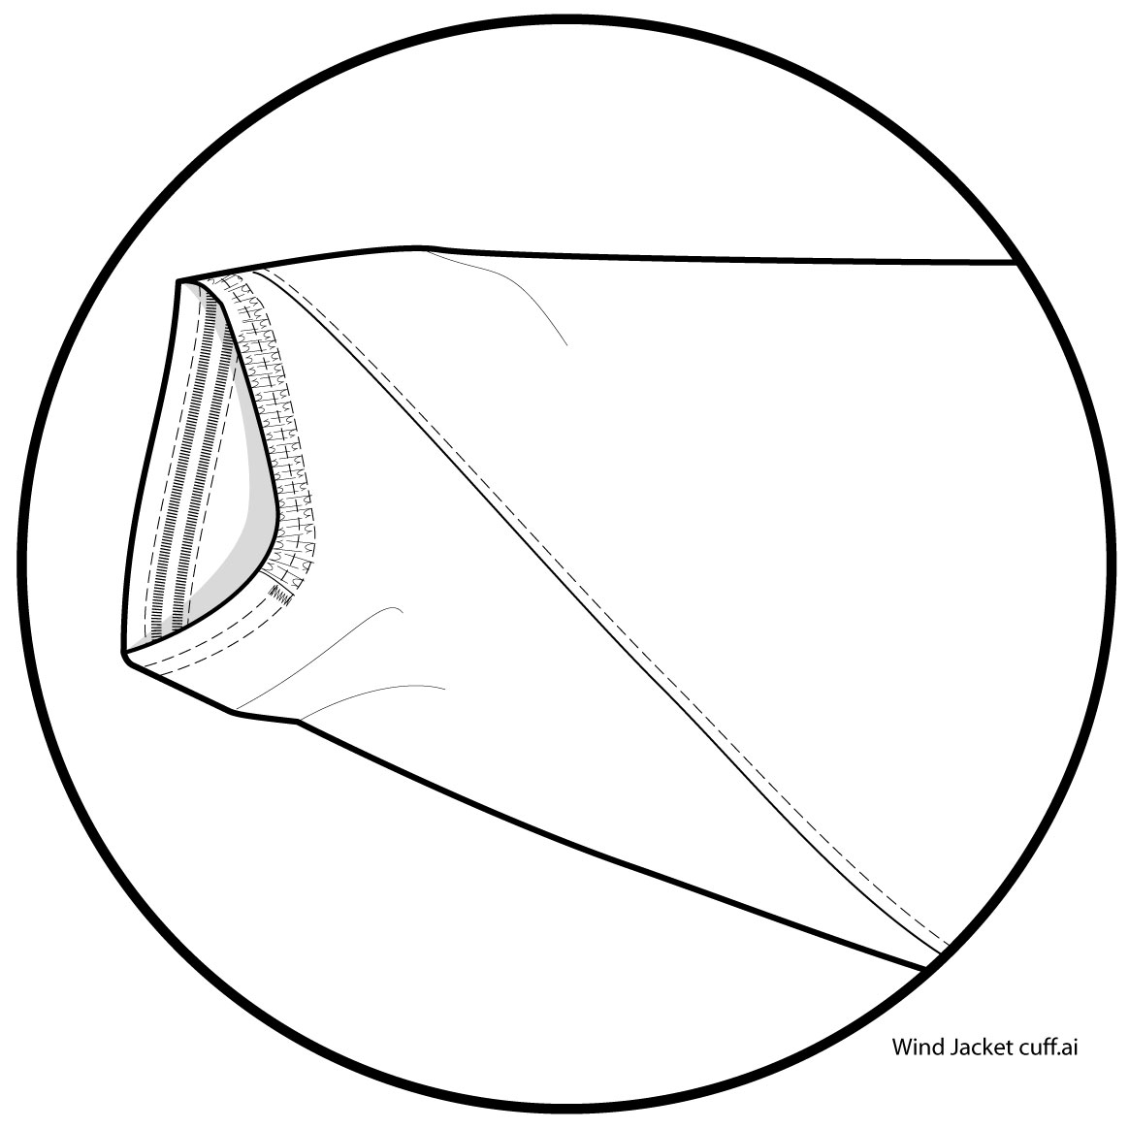
Figure 4
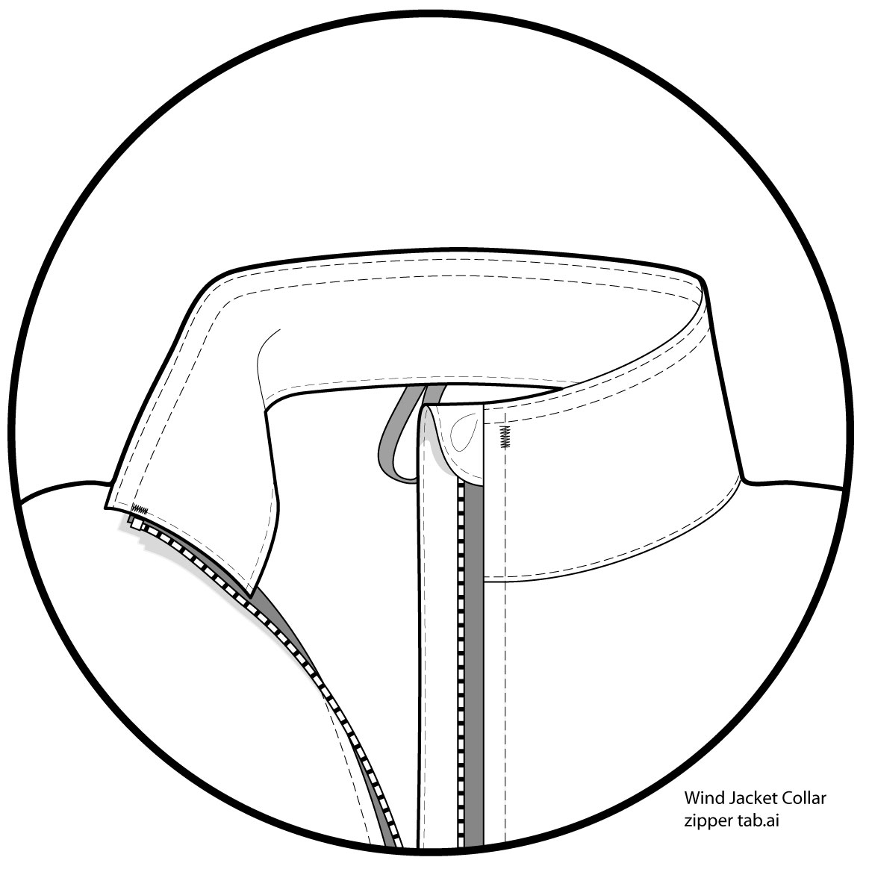
Figure 5

