INCH-POUND
GL/PD-06-18
5 July 2006

PURCHASE DESCRIPTION

TROUSERS, EXTREME COLD WEATHER (GEN III)

1. SCOPE

1.1 Scope. This purchase description covers requirements for insulated loft trousers, manufactured from a water repellent nylon cloth and batting material to be used as a component of the Extended Cold Weather Clothing System (ECWCS), GEN III.

1.2 Classification. The loft trousers shall be of one type in the following sizes as specified (see 6.2).

SCHEDULE OF SIZES

Size Small Medium Large X-Large

Regular X X X X

Long X X

2. APPLICABLE DOCUMENTS

2.1 General. The documents listed in this section are specified in sections 3 and 4 of this specification. This section does not include documents cited in other sections of this specification or recommended for additional information or as examples. While every effort has been made to ensure the completeness of this list, document users are cautioned that they must meet all specified requirements cited in sections 3 and 4 of this specification, whether or not they are listed.

2.2 Government documents.

2.2.1 Specifications, standards, and handbooks. The following specifications, standards, and handbooks form a part of this document to the extent specified herein. Unless otherwise specified, the issues of these documents are those cited in the solicitation or contract.

FEDERAL SPECIFICATIONS

V-T-295 - Thread, Nylon

FEDERAL STANDARDS

FED-STD-4 - Glossary of Fabric Imperfections

COMMERCIAL ITEM DESCRIPTIONS

A-A-55126 – Fastener Tapes, Hook and Loop, Synthetic
A-A-55634 – Zippers (Fasteners, Slide Interlocking)

DEPARTMENT OF DEFENSE SPECIFICATIONS

MIL-STD-129 – Military Marking for Shipment and Storage
MIL-PRF-5038 – Tape, Textile and Webbing, Textile, Reinforcing, Nylon
MIL-DTL-32075 – Label: For Clothing, Equipage, and Tentage, (General Use)

(Copies of these documents are available from the Acquisition Streamlining and Standardization Information System (ASSIST) database, online at http://assist.daps.dla.mil/quicksearch/ or www.dodssp.daps.mil or from the Standardization Document Order Desk, 700 Robbins Ave. Philadelphia, PA 19111-9054).

2.2.2 Other Government documents, drawings, and publications. The following other Government documents, drawings, and publications form a part of this document to the extent specified herein. Unless otherwise specified, the issues of these documents are those specified in the solicitation or contract.

CODE OF FEDERAL REGULATIONS

16 CFR Part 1500 – Federal Hazardous Substances Act Regulations
29 CFR Part 1910 – Occupational Safety and Health Standards

(Copies of these documents are available online at: www.access.gpo/nara/cfr or from the Superintendent of Documents, U.S. Government Printing Office, North capitol & “H” Streets, N.W., Washington, DC 20402-0002.)

2.3 Non-Government publications. The following documents form a part of this document to the extent specified herein. Unless otherwise specified, the issues of these documents are those cited in the solicitation or contract.

AMERICAN ASSOCIATION OF TEXTILE CHEMISTS AND COLORISTS (AATCC)

AATCC – 8 - Colorfastness to Crocking: AATCC Crockmeter Method
AATCC – 16 - Colorfastness to Light
AATCC – 22 - Water Repellency: Spray Test
AATCC – 61 - Colorfastness to Laundering, Home and Commercial: Accelerated
AATCC – 70 - Water Repellency: Tumble Jar Dynamic Absorption Test
AATCC – 96 - Dimensional Changes in Commercial Laundering of Woven and Knitted Fabrics, Except Wool
AATCC – 132 - Colorfastness to Dry Cleaning
AATCC – 135 - Dimensional Changes in Automatic Home Laundering of Woven and
Knitted Fabrics, Except Wool
AATCC – 150 - Dimensional Changes in Automatic Home Laundering of Garments

(Copies of these documents are available from www.aatcc.org or American Association of
Textile Chemists and Colorists (AATCC), P.O. Box 12215, Triangle Park, NC 27709-2215.)

AMERICAN SOCIETY FOR TESTING AND MATERIALS (ASTM)

ASTM C-518 - Steady-State Thermal Transmission Properties by Means of the Heat Flow Meter Apparatus
ASTM D-737 - Air Permeability of Textile Fabrics
ASTM D-747 - Apparent Bending Modulus of Plastics by Means of a Cantilever
Beam
ASTM D-751 - Coated Fabrics
ASTM D-1388 - Standard Test Method for Stiffness of Fabrics
ASTM D-1424 - Tearing Strength of Fabrics by Falling-Pendulum Type Apparatus
ASTM D-1776 - Practice for Conditioning and Testing Textiles
ASTM D-3775 - Warp End Count and Filling Pick Count of Woven Fabric
ASTM D-3776 - Mass Per Unit Area (Weight) of Fabric
ASTM D-5034 - Breaking Strength and Elongation of Textile Fabrics (Grab Test)
ASTM D-6193 - Practice of Stitches and Seams
ASTM E-96 - Water Vapor Transmission of Materials

(Application for copies are available from www.astm.org or American Society for Testing and Materials, 100 Barr Harbor Drive, West Conshohocken, PA 19428-2959.)

AMERICAN NATIONAL STANDARDS INSTITUTE

ANSI/ASQ Z1.4 – Sampling Procedures and Tables for Inspection by Attributes

(For all inquiries, please contact the American National Standards Institute, 25 West 43rd Street, 4th Floor, New York, NY 10036. Website address http://www.ansi.org)

(Non-Government standards and other publications are normally available from the organizations that prepare or distribute the documents. These documents also may be available in or through libraries or other informational services.)

MISCELLANEOUS

Principle and Methods of Toxicology, A Wallace Hayes (editor), pp 394-396, 1989.

(Copies of this document is available from Raven Press, 1185 Avenue of the Americas, New York, NY 10036)

Marzulli, F. and H. Maibach, “Contact Allergy: Predictive Testing in Humans,”
Advances in Modern Toxicology, Volume 4, pp 353-372, 1977.

(Copies of this document are available from the U.S. Army Center for Health Promotion and Preventative Medicine, ATTN: MCHB-DC-TTE, Bldg., E-2100, Aberdeen Proving Ground, MD 21010-5422.)

2.4 Order of precedence. In the event of a conflict between the text of this document and the references cited herein, the text of this document takes precedence. Nothing in this document, however, supersedes applicable laws and regulations unless a specific exemption has been obtained.

3. REQUIREMENTS

3.1 First article. When specified (see 6.3), a sample shall be subjected to first article inspection (see 4.2).

3.2 Recycled, recovered, or environmentally preferable materials. Recycled, recovered, or environmentally preferable materials should be used to the maximum extent possible provided that the material meets or exceeds the operational and maintenance requirements, and promotes economically advantageous life cycle costs.

3.3 Guide samples. Samples, when furnished, are solely for guidance and information to the contractor. Variations from the specification may appear in the sample in which case this specification shall govern.

3.3.1 Design. The trousers shall be Urban Gray 505 in color throughout, and shall have a 3-piece elastic webbing waistband. The waistband shall have a four nylon tab loops on the inside, two on the front, and two on the back. The fly slide fastener shall have a (2-way) coil zipper, with a full-length flap secured at the top of the waistband with hook & loop fastener tape. The let bottoms shall have a 1-piece elastic webbing to form a cuff. The outside of each leg (on the pant) shall have a full-length (2-way) individual element zipper from the waistband to the bottom of the leg cuff. The leg zippers shall have hook and loop fastener tapes at the waistband, and the bottom leg cuffs, in the closed position, shall be secured with hook & loop fastener tapes. The trouser shall have reinforced knees (see Figures 1-3).

3.4 Basic materials.

3.4.1 Standard Sample: All cloth materials shall match the applicable standard sample for shade and appearance on the face side, and shall be equal to or better than the standard sample with respect to all characteristics for which the standard sample is referenced (see 6.4).

3.4.1.1 Trouser layer shell (outside material). The cloth shall be a plain weave, nylon cloth (texture approximating 115 by 100 yarns per inch, warp and filling, respectively), meeting the requirements of Table I when tested as specified in 4.5. The color of the cloth shall be Urban Gray 505.
* 3.4.1.2 Physical requirements. The cloth shall conform to the physical requirements specified in Table I when tested as specified in 4.5.

TABLE I. Trouser Layer Shell (outside material), physical requirements

Characteristic | Requirement
Weight, oz/sq. yd (max.) | 3.3
Breaking strength, lbs (min.)
Warp | 100
Filling | 100
Tearing Strength, lbs. (min.)
Warp, Threshold | 4.0
Filling, Threshold | 4.0
Warp, Objective | 6.0
Filling, Objective | 6.0
Air Permeability, ft³/ft²/min. (max) | 1.0
Moisture vapor transmission
Rate, g/m²/24h (min.) -
Initial, Procedure B, Threshold | 800
Objective | 1200
Stiffness, in-lbs (max.)
At 70ºF, Objective | 0.001
Threshold | 0.002
At 32ºF, Objective | 0.001
Threshold | 0.002
Blocking, rating (max.) | No. 2
Water permeability, cm (min) -
Initial | 30
Spray rating, (min.) -
Initial | 100, 100, 90
After 5 launderings | 100, 90, 90
Resistance to organic liquid, pass/fail -
Initial | No wetting
After 5 launderings | No wetting
Dynamic absorption, percent (max.):
Threshold | 5.0
Objective | 1.5
Dimensional stability, percent (max.)
Warp | 2.5
Filling | 1.5
Color | Urban Gray 505
Spectral Reflectance, % | Table II
Colorfastness to:  Laundering | Equal to or better than “3-4” rating on AATCC Gray Scale for Color Change
Light | Equal to or better than “3-4” rating on AATCC Gray Scale for Color Change
Crocking | Equal to or better than the standard sample or not less than AATCC chromatic transference scale rating of 3.5
Toxicity | 1/
1/ The finished cloth shall not present a dermal health hazard when used as intended.

3.4.1.3 Color.

3.4.1.3.1 Urban Gray 505. The color of the face side of the cloth shall be Urban Gray 505, and shall match the applicable standard sample.

* 3.4.1.4 Spectral reflectance. The spectral reflectance shall conform to the requirements specified in Table II, initially, and after laundering when tested as specified in 4.5.

TABLE II. Spectral Reflectance Requirements: Reflectance (percent)

Wave length,  Nanometers (nm) | Urban Gray 505
Wave length,  Nanometers (nm) | Min | Max (Objective) Max (Threshold)
600 | 12 | 26 26
620 | 14 | 26 26
640 | 14 | 28 28
660 | 14 | 30 30
680 | 18 | 34 34
700 | 24 | 38 50
720 | 26 | 42 60
740 | 30 | 46 63
760 | 32 | 48 65
780 | 34 | 48 65
800 | 34 | 50 65
820 | 36 | 54 65
840 | 38 | 54 65
860 | 40 | 56 65

3.4.2 Nylon rip-stop cloth (lining cloth). The material for the inside of the loft pants (lining) shall be a rip-stop weave nylon cloth meeting the physical requirements specified in Table III when tested as specified in 4.5. The color of the cloth shall match Urban Gray 505.

TABLE III. Nylon Rip-Stop Cloth - Physical Requirements.

Characteristic | Requirement
Weight, oz/sq. yd (max.) | 1.7
Construction, yarns/inch (min.)
Warp | 180
Filling | 96
Break Strength, lbs. (min.)
Warp | 115
Filling | 80
Tearing Strength, lbs. (min.)
Warp | 7.5
Filling | 5.0
Air Permeability, ft³/ft²/min. (max) | 1.0 – 3.0
Color | Urban Gray 505
Spectral Reflectance, % | Table II
Colorfastness to:
Laundering | Equal to or better than “3-4” rating on AATCC Gray Scale for Color Change
Light | Equal to or better than “3-4” rating on AATCC Gray Scale for Color Change
Crocking | Equal to or better than the standard sample or not less than AATCC chromatic transference scale rating of 3.5
Toxicity | 1/
1/ The finished cloth shall not present a dermal health hazard when used as intended.

3.4.3 Batting material (insulation). The batting material used to insulate the loft trousers shall conform to the physical requirements specified in Table IV. Testing shall be as specified in 4.5.

TABLE IV. Batting Material (insulation) - Physical Requirements.

Characteristic | Requirement
Weight oz./sq.yd | 6.0+/-0.6
Thickness @0.002 psi, in., max. | 1.0
Warmth @0.002psi, clo/oz./sq yd, min. | 0.74
Drape stiffness, inches, max. | 4.0
Water Gain, wt.%, max. | 400%
Dimensional stability, percent max.
After 5 Launderings
Machine/Warp  Cross Machine/filling | 10.0  10.0
Toxicity | 1/
1/ The finished cloth shall not present a dermal health hazard when used as intended.

3.4.4 Cloth, nylon (reinforcing material). The cloth for use as knee patches shall be a plain weave, nylon cloth finished to meet the physical requirements of Table V, when tested as specified in 4.5. The color of the cloth shall be Urban Gray 505.

TABLE V. Nylon Cloth (reinforcing material) - Physical Requirements.

Characteristic | Requirement
Weight, oz/sq. yd (max.) | 5.5
Yarns per inch (min.) -
Warp | 58
Filling | 38
Breaking strength, lbs (min.)
Warp | 280
Filling | 180
Tearing Strength, lbs. (min.)
Warp | 8.0
Filling | 8.0
Stiffness, in-lbs (max.)
At 32ºF | 0.001
At 70ºF | 0.001
Blocking, rating (max.) | No. 2
Spray rating, rating -
Initial | 100, 100, 90
After 1 laundering | 100, 90, 90
Resistance to organic liquid, pass/fail -
Initial | No wetting
After 1 laundering | No wetting
Dynamic absorption, percent (max.) | 1/
Dimensional stability, percent (max.)
Warp | 2.0
Filling | 1.0
Color | Urban Gray 505
Spectral Reflectance, % | Table II
Colorfastness to:
Laundering | Equal to or better than “3-4” rating on AATCC Gray Scale for Color Change
Light | Equal to or better than “3-4” rating on AATCC Gray Scale for Color Change
Crocking | Equal to or better than the standard sample or not less than AATCC chromatic transference scale rating of 3.5
Toxicity | 2/
1/ The cloth shall show not more than a 25 percent increase in dynamic absorption
properties after one laundering when compared to an unlaundered sample of cloth.
2/ The finished cloth shall not present a dermal health hazard when used as intended.

3.5 Components.

3.5.1 Elastic webbing. The elastic webbing used in the waistband and leg cuffs shall be
1-1/2 inches wide, natural in color and it shall be equal to or better than Style 9257of South Carolina Elastic Co., Landrum, SC 29356.

3.5.2 Tape, nylon. The tape for the loops in the waistband (4), and the loops in each trouser leg (2) shall conform to type III, ¾ inch wide flat nylon tape, of MIL-PRF-5038. The color of the tape shall be Urban Gray 505.

3.5.3 Fastener tape, hook and loop. The hook and loop fastener tape shall conform to type II, class 1 of A-A-55126, with selvage edges. No slit or split edges are permitted. Sew all hook and loop minimum of 1/8 inch from bound selvage to prevent needle cutting along edges. To prevent raveling, do not sew directly on selvage. However, each required width shall maintain a tolerance of +1/32 inch as to prevent stitching runoffs or improper fit into automatic sewing equipment. The color shall match Urban Gray 505.

3.5.3.1 Alternate tape, loop. As an alternate, loop fastener tape without selvages edges (reduce field fraying) shall conform to class 1 of A-A-55126 except without selvage edges: YKK Cosmolon Edge to Edge" with heat-sealed edges or Velcro "DD", an edge-to-edge loop tape. Sew all loop tape minimum of 1/8 inch from edge to prevent needle cutting along edges. However, each required width shall maintain a tolerance of +1/32 inch as to prevent stitching runoffs or improper fit into automatic sewing equipment. The color shall match Urban Gray 505.

3.5.3.2 Alternate tape, hook. As an alternate to hook tape without selvages (reduce field fraying), the following products may be used: Extruded plastic hook tape identified as "Velcro brand HTH 841" or "YKK brand SA200A". The color shall match Urban Gray 505.

3.5.3.3 Colorfastness, tape hook and loop. Unless otherwise specified, for Urban Gray 505, the fastener tapes (hook and loop) shall show fastness to dry cleaning (if required by contract), light (170 Kilojoules), laundering (after 5 cycles) and crocking when tested in paragraph 4.5. The finished tape fasteners shall show fastness equal to or better than a rating “ 4-5 “ to dry cleaning and light, equal to or better than a rating of “2-3” for laundering using AATCC Gray Scale for Color Change and equal to or better that rating of “4” for crocking using AATCC Chromatic Transference Scale. The color depreciation for laundering and light shall remain in the same hue as compared to the original sample. (Hue/cast is defined as the attribute of color that classifies a color as red, blue, green etc.)"

3.5.3.4 Hook and loop laundry durability test method. When tested in accordance with 4.6.11 the hook and loop tapes shall not exhibit fraying edges, peeling yarns, or damage appearance that detracts from the tape appearance or durability.

3.5.4 Interfacing.

3.5.4.1 The interfacing fabric used on the side tabs (with the hook and loop), the leg cuff tabs, and the fly cover shall be Pellon # 933 material or equal .

3.5.4.2 The side leg slide fastener (zipper) flap interfacing shall be 1-inch wide commercial nylon tape that is durable for the life of the garment.

3.5.5 Fasteners, slide, interlocking. All slide fasteners shall conform to A-A-55634, with the types and styles as specified below.

3.5.5.1 Fly slide fastener. The fly slide fastener (zipper) shall be plastic continuous element, Type I, Style 13 (double slider, mouth-to-mouth, autolock, that allows the zipper to open from top and bottom), No. 5 chain, with 175 lbs. (min.) crosswise strength. The zipper shall be connected/attached to water repellent treated tape, and each slider shall have long pull tabs with thongs. The material for the thongs shall be ¼ inch nylon tape binding. The color of the slide fastener and thong shall be Urban Gray 505.

3.5.5.2 Side leg slide fastener. The side leg slide fasteners (zippers) shall be plastic individual element, Type III, Style 13 (separating, except separating pins shall be set at top waistband level, double slider, mouth-to-mouth, autolock, that allows the zipper to open from top and bottom), No. 5 chain with 100 lbs. (min.) crosswise strength. The zippers shall be connected/attached to water repellent treated tape, and each slider shall have long pull tabs with thongs, except that the bottom slider thongs shall be shortened to ¾ to 1 inch finished length. The material for the thongs shall be ¼ inch nylon tape binding. The color of the slide fastener and thong shall be shall be Urban Gray 505.

* 3.5.6 Thread. The thread for all seaming and stitching shall be Type I or II, size B, 2-ply at
6.0 pounds breaking strength, with a “Water repellent” treatment, conforming to V-T-295. As an alternate, bobbin/looper thread can be Nylon, size AA, 2-ply, with a minimum breaking strength of 4.0 pounds with a “Water-Repellent” finish. Stitching shall be 9-12 stitches per inch, lockstitch. The color of the thread shall be Urban Gray 505.

3.5.7 Labels. Each trousers shall have a label in accordance with Type VI, Class 14 of MIL-DTL-32075. The color of the labels shall approximate the ground shade of the basic fabric or White. In addition it shall contain a bar coding label in accordance with Type VIII and Class 17.

3.5.7.1 The combination size, identification and instruction label for the trousers. The combination label shall be sewn on the inside of the trouser along the back seam of the waistband. The printed label shall be facing the body. The instruction label shall include the following information:

Trousers, Extreme Cold Weather
Care Instruction Label
LAUNDERING: (DO NOT DRY CLEAN)

a. Home Laundering. The trousers shall be machine laundered using the
delicate/gentle fabric cycle or laundered by hand. Use cold water (up to 90ºF/32º
C) and cold water laundry detergent (i.e. Liquid Tide or Era Plus). Rinse in clean
cold water. DO NOT STARCH OR BLEACH. Dry in a tumble dryer at
temperature not exceeding 130ºF(54ºC) as degradation of the component
materials will result. Avoid over drying. To drip dry, place on rustproof hanger.
DO NOT PRESS.
b. Field Laundering. The trousers shall be field laundered using Formula II of
FM 42-414, Appendix E. DO NOT STARCH OR BLEACH.

3.6 Patterns. Standard patterns providing a seam allowance of ½ inch for out seams, seat seams and crotch seams, and a 3/8 inch allowance for all other seams, except where otherwise specified, will be furnished by the Government. The pattern list in Table VI is provided to insure that the pattern set provided is complete. The Government patterns shall not be altered in any way, and are to be used only as a guide for cutting the contractor’s working patterns. The working patterns will be identical to the Government patterns, except that additional notching to facilitate manufacture is possible. Also, minor modifications are permitted where necessary to accommodate manufacturer’s processes and using automatic equipment. These modifications shall not alter the serviceability or appearance requirements.

3.6.1 Pattern parts. The component parts shall be cut from the materials indicated and in accordance with the pattern parts listed in Table VI.

TABLE VI. List of Pattern Parts

Material | Pattern Abbreviation | Nomenclature
Shell (outside) | ECLB-BK | Back
 | ECLB-BOTINBK | Bottom Inner Back
 | ECLB-FRT | Front
 | ECLB-SIDEZIPFLP | Side Zipper Flap
 | ECLB- Hook & Loop | Hook and Loop Guide
 | ECLB-BOTFRT | Bottom Inner Front
Reinforcing | ECLB-KNEE | Knee
Batting & Rip-Stop | ECLB-BKLINING | Back Lining
 | ECLB-FRT-LINING | Front Lining
Interfacing & Shell | ECLB-SDFLPCLOSE | Side Flap Closure
 | ECLB-SDLEGZIP | Side Leg Zipper
 | ECLB-CRTCHZIP | Crotch Zipper (Fly)
 | ECLB-FRTZIPFLAP | Front Zipper Flap

* TABLE VI-A. Slide Fastener Lengths (Inches).

Location | Size of Garment
Location | Sm | Med | Lg | XLg | Lg –  Long | XLg –  Long
Fly | 10-1/2 | 11 | 11 | 11-1/2 | 11-1/2 | 12
Side leg | 42-1/4 | 42-3/4 | 43-1/4 | 43-3/4 | 45-3/4 | 46-1/4

3.7 Stitches, seams, and stitching. All stitches, seams and stitching shall conform to ASTM-D-6193. The type of seam and stitching shall be as specified in Table VII. Seam allowances shall be maintained with seams sewn so that no raw edges, run-offs, pleats, puckers or open seams occur.

3.7.1 Type 301 stitching. Ends of all stitching shall be backstitched or overstitched not less than ½ inch except where ends are turned under or caught in other seams or stitching. Ends of a continuous line of stitching shall over-lap not less than ½ inch. Thread tensions shall be maintained so that there will be no loose stitching resulting in loose bobbin or top thread or excessively tight stitching resulting in puckering of the materials sewn. The lock shall be embedded in the materials sewn.

3.7.1.1 Repairs of type 301 stitching.

a. When thread breaks, skipped stitches, run-offs, or bobbin run-outs occur during sewing, the stitching shall be repaired by restarting the stitching a minimum of ½ inch back of the end of the stitching. 1/

b. Except for pre-stitching, thread breaks or two or more consecutive skipped or run-off stitches noted during inspection of the item shall be repaired by overstitching. The stitching shall start a minimum of ½ inch in back of the defective area, continue over the defective area, and continue a minimum of ½ inch beyond the defective area onto the existing stitching. Loose or excessively tight stitching shall be repaired by removing the defective stitching without damaging the materials, and re-stitching in the required manner. 1/

1/ When making the above repairs, the ends of the stitching are not required to be backstitched.

3.7.1.2 Automatic stitching. Automatic machines may be used to perform any of the required stitch patterns provide the requirements for the stitch pattern, stitches per inch, and size and type of thread are met; and at least three tying, overlapping or back stitches are used to secure the ends of the stitching.

3.7.1.3 Thread ends. All thread ends shall be trimmed to a length of not more than ¼ inch unless otherwise specified.

* 3.7.2 Seaming. All seams shall be consistent and exhibit a uniform appearance and conform to the ASTM D 6193 stitch and seam types listed in Table VII. The backside of seams (inside garment) shall be flat with no protruding seam allowance to create irritation or discomfort. The seams shall be sewn with 9-12 stitches per inch for all outside visible stitching. The width of the bight of stitching shall not be less than 1/16 inch. All material edges shall be clean finished, either, turned-in, turned-under, or serged.

Table VII. Seam and Stitching Types

Seam placement | Seam type | Stitch type
Side seams, backseam and inseam | LSc-2 | 301
Attachment of knee patches | LSd-1 or LSd-2 | 301
Bottom hemming | Efb-1 | 301
Waistband lining | OSf-1 | 301
Hook/Loop | OSF-1 | 301
Zippers | -- | 301

4. VERIFICATION

4,1 Classification of inspections. The inspection requirements specified herein are classified as follows:
1. First article inspection (see 4.2).
2. Conformance inspection (see 4.3).

4.2 First article inspection. When a first article is required (see 3.1 and 6.3), it shall be
examined for the defects specified in 4.4.1.1, the finished dimensions in 4.4.2 and performance as specified in 4.4.1 and 4.5.

4.3 Conformance inspection. Sampling for inspection shall be performed in accordance with ANSI/ASQ Z1.4, as defined by contract, except where otherwise specified.

4.4 Component and end item inspections. In accordance with 4.1, components and materials in the end items shall be tested in accordance with all the requirements of referenced documents unless otherwise excluded, amended, modified or qualified in this document or applicable procurement documents. The government reserves the right to inspect all components and end items to determine conformance to requirements.

4.4.1 Component and material certification. Unless otherwise specified, a certificate of compliance will be acceptable as evidence that the requirements of 3.4 and 3.5 are met. When certificate of compliance are submitted, the Government reserves the right to inspect such items to determine the validity of the certification.

4.1.1.1 End item visual examination. Each pair of pants shall be subjected to a visual examination. All fabric and garment defects shall be scored in accordance with Tables VIII and VIIIA. Material defects are defined in Section I of FED-STD-4. All shade evaluation of the garment shall be evaluated at a distance of 3 feet and under the artificial daylight in 4.6.6.

TABLE VIII. Material Visual Examination

Examination | Defect
Materials | Hole, cut, tear, smash, burn, exposed drill hole, run, thin place, dye streak, color not as specified, misweave, visible mend  Knots greater than Sears Scale Level C (See 6.6)  Slubs greater than Sears Scale Level D (See 6.6)

TABLE VIIIA. Trouser Visual Examination

Examination | Defect
Component Part | Component part of trouser omitted, not as specified, distorted, full, tight, or twisted; any part of trouser caught in unrelated stitching, the edge of any component part required to be forced out having folds of more than 1/8 inch fullness creating unwanted permanent fold, pleat, or crease in fabric or garment
Stitching and Seams | Trouser seam: open stitching, puckered, distorted, pleated, wavy, twisted, irregular, or loose or tight stitch tension, broken or missing thread or stitch, needle chew, , edge or raise stitching sewn too close to the edge resulting in damage to cloth, seam allowance not as specified, no visible raw edge (more than one occurrence of inside raw edge greater than 1 inch)  Stitching not as specified  Run off of more than ½ inch for edge and raised stitching  Thread color not as specified
Evenness | Waistband uneven by more that ¼ inch when slide fastener is closed  Inseam and/or outseam lengths vary by more than ½ inch  Bottom openings vary by more than ½ inch in half width  Evenness of length between inseam and outseam varies by more than ½ inch
Hook & Loop | Hook & Loop misplaced, damaged or omitted, twisted or distortion when closed, out of alignment causing bulge  Hook & Loop out of alignment by more than ¼ inch  Hook & Loop color or type not as specified
Slide fastener | Any part of slide fastener bent, broken, missing or otherwise defective; not closing as specified; length not as specified; color not as specified; thong not as specified
Hems | Hem of pant bottom less than ¾ inch or more than 1-inch  Hems twisted, wavy omitted or not as specified
Shade | Shade variation within part of between parts
Nylon Loops | Nylon Loops inside of waistband (4), and on inside of leg cuffs (2 each leg) omitted, insecure, not specified size, openings not as specified
Knee Patches | Knee patches omitted, not attached as specified, not type specified
Cleanness | Spot stain, excessive thread ends not less than ¼ inch (more than 3) not trimmed or removed, odor, affecting appearance or serviceability
Labels | Any label omitted, incorrect, illegible, not attached where specified Bar Code/UPC code omitted, not readable by scanner; human readable interpretation (HRI) omitted or illegible  Bar code/UPC code not visible on folded, package item bar code attachment causes damage to the item
Packaging | Any trouser not packaged in accordance with contract or purchase order

* 4.4.2 Finished measurements. The trousers shall conform to the finished measurements specified in Table IX.

Table IX. Finished Measurements (Inches)

Size | Tolerance | Small  Reg | Medium  Reg | Large  Reg | Large Long | X Large  Reg | X Large Long
Waist ½  relaxed | -1/4, +1/2 | TBD | 18 ½ | TBD | TBD | TBD | TBD
Inseam | -1/4, +1/2 | TBD | 30 ½ | TBD | TBD | TBD | TBD

Description | Measurement
½ Waist, Relaxed | Measurement taken from folded edge to folded edge with garment laid flat and relaxed and with fly and waist closure closed.
Inseam Length | Measurement taken from the bottom of the front rise to the leg cuff.

4.5 Basic material testing. The basic material specified in 3.4 through 3.4.4 shall be tested for the characteristics listed in Table X in accordance with the test method cited.

TABLE X. Basic Material Testing

Characteristic | Reference paragraph | Test method
Trouser layer shell (outside material)
Fiber identification, weave and fabric count |  | 1/
Weight | 3.4.1.2 | ASTM D-3776
Break strength | 3.4.1.2 | ASTM D-5034 (GE or GT)
Tearing strength | 3.4.1.2 | ASTM D-1424
Air permeability | 3.4.1.2 | ASTM D-737
Moisture vapor transmission | 3.4.1.2 | 4.6.1 & 4.6.1.1
Stiffness
At 70°F | 3.4.1.2 | ASTM D-747 5/
At 32°F | 3.4.1.2 | 2/ & ASTM D-747 5/
Blocking | 3.4.1.2 | 4.6.2
Water permeability
Initial | 3.4.1.2 | 4.6.3
Spray rating
Initial | 3.4.1.2 | 4.6.4.1
After 5 launderings | 3.4.1.2 | 4.6.4.3 & 4.6.4.1
Resistance to organic liquid
Initial | 3.4.1.2 | 4.6.5.1
After 5 Launderings | 3.4.1.2 | 4.6.5.3
Dynamic Absorption | 3.4.1.2 | AATCC-70
Dimensional stability | 3.4.1.2 | AATCC-96, option 1C
Color | 3.4.1.2 | 4.6.6
Spectral reflectance | Table II | 4.6.7 and 4.6.7.1
Colorfastness to:
Laundering | 3.4.1.2 | 4.6.8.1
Light | 3.4.1.2 | 4.6.8.2
Crocking | 3.4.1.2 | AATCC-8
Toxicity | 3.4.1.2 | 4.6.10
Nylon Rip-stop cloth (lining material)
Fiber identification and weave |  | 1/
Weight | 3.4.2 | ASTM D-3776 (Method C)
Fabric count, yarns/ inch | 3.4.2 | ASTM D-3775
Break strength | 3.4.2 | ASTM D-5034 (G-E or G-T)
Tearing strength | 3.4.2 | ASTM D-1424
Air permeability | 3.4.2 | ASTM D-737
Color | 3.4.2 | 4.6.6
Spectral reflectance | Table II | 4.6.7
Colorfastness to:
Laundering | 3.4.2 | 4.6.8.1
Light | 3.4.2 | 4.6.8.2
Crocking | 3.4.2 | AATCC-8
Toxicity | 3.4.2 | 4.6.10
Batting Material (insulation)
Weight | 3.4.3 | ASTM D-3776
Thickness | 3.4.3 | 3/
Warmth @ 0.002psi | 3.4.3 | ASTM C-518
Drape stiffness | 3.4.3 | ASTM D-1388
Water gain | 3.4.3 | 4/
Dimensional stability | 3.4.3 | AATCC 135(1)(V)(A)(i)
Toxicity | 3.4.2 | 4.6.10
Cloth, Nylon (reinforcing material for knee patches)
Weight | 3.4.4 | ASTM D-3776 (Method C)
Yarns per inch | 3.4.4 | ASTM D-3775
Breaking strength | 3.4.4 | ASTM D-5034 (G-E or G-T)
Tearing strength | 3.4.4 | ASTM D-1424
Stiffness | 3.4.4 | 4.6.9
At 70°F | 3.4.4 | ASTM D-747 5/
At 32°F | 3.4.4 | 2/ & ASTM D-747 5/
Blocking | 3.4.4 | 4.6.2
Spray rating | 3.4.4
Initial | 3.4.4 | 4.6.4.1
After 1 laundering | 3.4.4 | 4.6.4.2 & 4.6.4.1
Resistance to organic liquid
Initial | 3.4.4 | 4.6.5.1
After 1 laundering | 3.4.4 | 4.6.5.2
Dynamic absorption | 3.4.4
Initial |  | AATCC-70
After 1 laundering |  | 4.6.8.1.1 & AATCC -70
Dimensional stability | 3.4.4 | AATCC-96, Option 1C
Color | 3.4.4 | 4.6.6
Spectral reflectance | Table II | 4.6.7 and 4.6.7.1
Colorfastness to:
Laundering | 3.4.4 | 4.6.8.1
Light | 3.4.4 | 4.6.8.2
Crocking | 3.4.4 | AATCC-8
Toxicity | 3.4.4 | 4.6.10
Fastener Tape, Hook and Loop
Color | 3.5.3 | 4.6.6
Colorfastness To:
Dry cleaning | 3.5.3.3 | AATCC -132
Light | 3.5.3.3 | 4.6.8.2
Laundering after 5 cycles | 3.5.3.3 | AATCC – 61, Opt. 3A
Crocking | 3.5.3.3 | AATCC - 8
Laundry Durability | 3.5.3.4 | 4.6.11- 4.6.11.4
1/ A certificate of compliance shall be submitted for these requirements.
2/ The test specimens and testing machine shall be exposed to 32ºF + 2ºF for 4 hours. The
test shall then be performed in still air at that temperature.
3/ Batting thickness shall be measured on panels using a 12” x 12” calibrated Measure-Matic
Thickness Gauge, or equivalent, under a pressure of 0.002 pounds per inch (psi).
4/ The insulation should adsorb a maximum weight gain in water when subjected to room
temperature distilled water for 20 minutes with excess water when removed via
centrifugation at 1500rpm for 5 minutes.
5/ Stiffness (bending moment) shall be conducted in accordance with ASTM D-747 except as follows:

a. Unless otherwise specified, the testing conditions shall be in accordance with ASTM D-1776.
b. The test specimen shall be a rectangle of cloth of dimensions two (2) by one (1) inches with the long dimension parallel to the fabric direction under test, warp or filling, as applicable.
c. The load scale reading shall be recorded only at the specimen angular deflection of 60 degrees.
d. The stiffness is the bending moment of specimen at a deflection angle of 60 degrees and shall be calculated to three significant figures as follows:

Bending moment, in.-lb. = Load scale reading x moment weight*
100

* Testing machine of Tinius Olsen Testing Machine Co.

4.6 Methods of testing. All testing shall be done in a standard condition environment defined by the ASTM D-1776, if not specifically defined by the individual test procedure.

4.6.1 Moisture Vapor Transmission Rate. ASTM E-96 with temperature and humidity conditions of 73.5° + 1°F and 50 + 2% R.H. The linear air flow velocity in the wind tunnel shall be set to yield an upright, ‘open cut’ evaporation rate at all test specimen positions of 15000 + 1000 g/m²/24h (The evaporation rate shall be determined by conducting an upright cup, Procedure B test (see 4.6.1.1), without a test specimen for a period of exactly two (2) hours).

4.6.1.1 Procedure B, ASTM E-96. The backside of the basic material shall face the water. The test specimen shall be conditioned, after set-up in the test cup with water level of ¾ + 1/16 inch below the specimen surface, in the wind tunnel for a period of not less than four (4) hours and not more than sixteen (16) hours (Conditioning time of less than 4 hours may be used provided that equilibrium conditions have been demonstrated to exist within the test sample/sample cup/wind tunnel. In cases of dispute, the conditioning time shall be 4 hours). After conditioning, the cup shall be immediately weighed to start the test and again after exactly twenty-four (24) hours to complete the test. Five (5) specimens shall be tested.

4.6.2 Blocking. ASTM D-751, Blocking Resistance at Elevated Temperatures, except that the test shall be performed at a temperature of 180° + 2°F for 30 minutes. Only one (1) specimen shall be tested. Evaluate the resistance of the specimen to blocking by the scale given below:

1 – No Blocking. Cloth surfaces are free and separate without any evidence of cohesion or adhesion.
2 – Trace Blocking. Cloth surfaces show slight cohesion or adhesion.
3 – Slight Blocking. Cloth surfaces must be lightly peeled to separate.
4 – Blocking. Cloth surfaces separate with difficulty or coating is removed during separation.

4.6.3 Water permeability. ASTM D-751, Hydrostatic Resistance, Procedure B, Procedure 1 with a rising hydrostatic head at 10 mm/sec applied to the face side of the test specimen. Five (5) specimens shall be tested. Leakage is defined as the appearance of one (1) or more droplets of water within the 4-1/2 inch diameter test area.

4.6.4 Spray rating.

4.6.4.1 Initial. Testing shall be conducted in accordance with AATCC-22

4.6.4.2 After 1 laundering. (for cloth, nylon (reinforcing)). Test specimens shall be laundered for one (1) laundering cycle in accordance with AATCC-96, Test VI, A.

4.6.4.3 After 5 launderings. Test specimens shall be laundered for five (5) laundering cycles in accordance with 4.6.8.1.1 and ten tested for spray rating in accordance with 4.6.4.1.

4.6.5 Resistance to organic liquids.

4.6.5.1 Initial. Place a small specimen of the cloth on a smooth horizontal surface, face side up. Using a pipette or eyedropper, gently deposit one (1) drop of n-tetradecane on the surface of the specimen. After 30 seconds, examine the specimen under light at an angle. Absence of light reflectance at the cloth/drop interface shall be taken as evidence of wetting. Three (3) specimens (or areas) taken at various locations across the sample unit shall be tested. Evidence of wetting on one (1) or more specimens shall be considered a test failure.

4.6.5.2 After 1 laundering (for cloth, nylon (reinforcing). Test specimens shall be laundered for one (1) laundering cycle in accordance with AATCC-96, Test VI, A.

4.6.5.3 After 5 launderings (on loft layer shell fabric). Test specimens shall be laundered for five (5) laundering cycles in accordance with 4.6.8.1.1 and then tested for resistance to organic liquids in accordance with 4.6.5.1.

4.6.6 Color matching. The color and appearance of the cloth shall match the standard sample when viewed using the AATCC Evaluation Procedure 9, Option A, with sources simulating artificial daylight and that have a correlated color temperature of 7,500º + 200ºK, with illumination of 100 + 20 foot candles, and shall be a good match to the standard sample under incandescent lamplight at 2,300º + 200ºK.

4.6.7 Spectral reflectance. Spectral reflectance data shall be determined on the face side and shall be obtained from 600 to 860 nanometers (nm) at 20nm intervals on a spectrophotometer relative to the barium sulfate standard, the preferred white standard. Other white reference materials may be used provided they are calibrated to absolute white, e.g., magnesium oxide or vitolite tiles. The spectral bandwidth shall be less than 26nm at 860nm. Reflectance measurements may be made by either the monochromatic or polychromatic mode of operation. When the polychromatic mode is used the spectrophotometer shall operate with the specimen diffusely illuminated with the full emission of a source that simulates either CIE source A or CIE source D65. The specimen shall be measured as a single layer, backed with six layers of the same fabric and shade. Measurements shall be taken on a minimum of two (2) different areas and the data averaged. The measured areas should be at least 6 inches away from the selvage. The specimen shall be viewed at an angle no greater than 10 degrees from normal, with the specular component included. Photometric accuracy of the spectrophotometer shall be within 1 percent and wavelength accuracy within 2 nm. The standard aperture size used in the color measurement device shall be 1.0 to 1.25 inches in diameter. Any color having spectral reflectance values falling outside the limits at four or more of the wavelengths specified shall be considered test failure.

4.6.7.1 Accelerated laundering (Spectral Reflectance Durability Test.). The cloth shall be laundered separately in accordance with AATCC-61 (Option 3A) except that a 4-gram sample size shall be used (Note: A sample size large enough to evaluate the spectral reflectance shall be used) and that the procedure shall be conducted using (10) stainless steel spheres and the 1993 AATCC Standard Reference Detergent without optical brightener. The samples shall then be evaluated for spectral reflectance in accordance with 4.6.7.

4.6.8 Colorfastness.

4.6.8.1 Laundering. AATCC-61, Test 1A (3 cycles) except that 1993 AATCC Standard Reference Detergent (non-phosphate) without optical brighteners shall be used.

4.6.8.1.1 Laundering procedure. Place 2.0 + 0.2 pounds of the cloth and, if needed, ballast in an automatic washing machine set on permanent press cycle, high water level and warm (100°F + 10°F, -0°F) wash temperature. Place 0.5 ounce (14 grams) of 1993 AATCC Standard Reference Detergent (non-phosphate) without optical brighteners into the washer. The duration of each laundering cycle shall be 30 + 5 minutes. After laundering, place sample and ballast in an automatic tumble dryer set on permanent press cycle, 150°F - 160°F, and dry for approximately fifteen (15) minutes. The laundering equipment, washer and dryer, shall be in accordance with AATCC-135.

4.6.8.1.2 Light. AATCC-16, Option A (after 40 fading units) or E (after 170 kilojoules).

4.6.9 Stiffness. ASTM D-747.

4.6.10 Toxicity assessment. The contractor must furnish information, which certifies that the finished product is composed of materials, which have been safely used commercially or provided sufficient toxicity data to show compatibility with prolonged, direct skin contact. At a minimum, toxicity data should include results from a primary dermal irritation study in laboratory animals and a repeated insult human patch test (Modified Draize Procedure). The latter must be conducted under the supervision of a qualified dermatologist using at least 100 free-living individuals.

4.6.10.1 Toxicity documents. All finishes/chemicals used to process the garment shall be identified and accompanied by the appropriate Material Safety Data Sheet (MSDS) information. The use of chemicals recognized by the Environmental Protection Agency (EPD) as human carcinogens is prohibited.

4.6.11 Hook and loop laundering durability test method procedures. The hook and loop tape shall meet the requirements stated in 3.5.3.4 when tested for laundry durability. Use test replica or garment test sample method to verify laundry durability.

4.6.11.1. Test Replica Sample Preparation. Fabricate two test replica samples from basic material paragraph 3.4.1.1. One test replica sample shall contain hook tape on the outer surface and the other test replica sample shall contain loop tape on the outer surface. Finished dimensions of each test replica sample shall be 20-inches by 20-inches. The hook and loop tape, paragraphs 3.5.3 - 3.5.3.2, sewn to the test sample shall represent production widths, lengths and quantities used in trouser fabrication. Evenly distribute hook and loop tape pieces on both sides of each test replica sample. Sewn hook and loop pieces with box stitch 1/8-inch to 3/16-inch from selvage using 301 stitch type. Insert fabric squares into test replica sample to achieve 1.4 pound minimum weight per test sample. Close test replica sample and stitch around entire sample to prevent curling and balling up of internal fabric squares.

4.6.11.2 Alternate Garment Test Sample. As an alternate, use two (2) loft trousers sewn with representative hook and loop tapes used in production shall be laundered as a set. To assess worse case situation of hook and loop failure during laundry test, do not engage hook and loop tapes or slide fastener (zipper).

4.6.11.3 Wash Procedures for Test Replica Samples or Alternate Garment Test Samples. Launder two test replica samples, one hook sample and one loop sample, two loft trousers, with test method AATCC-150 which includes sample and ballast load weighing a total of 4-pounds. Note: For Garment Sample, do not engage hook and loop tapes to represent worse case situation. Wash setting shall be Permanent Press, 140°F wash and 80°F rinse with a 10 minute agitation time. Use 66 grams of detergent conforming to 1993 AATCC detergent without bleach for each laundering. Drying time shall be Permanent Press for 40-45 minutes.

4.6.11.4 Number of Laundering/Drying Cycles. A total of 10 laundering and drying cycles for each test replica sample set or loft trouser sets.

5. PACKAGING

5.1 Packaging. For acquisition purposes, the packaging requirements shall be as specified in the contract or order (see 6.2). When packaging of materiel is to be performed by DoD or in-house contractor personnel, these personnel need to contact the responsible packaging activity to ascertain packaging requirements. Packaging requirements are maintained by the Inventory Control Point’s packaging activities within the Military Service or Defense Agency, or within the military service’s system commands. Packaging data retrieval is available from the managing Military Department’s or Defense Agency’s automated packaging files, CD-ROM products, or by contacting the responsible packaging activity.

6. NOTES

(This section contains information of a general or explanatory nature that may be helpful, but is not mandatory.)

6.1 Intended use. The ECWCS, GEN III loft trousers is intended for use by personnel of the Department of Defense as a component of the Extended Cold Weather Clothing System. The principle purpose is to provide protection against the adverse effects of extreme cold weather.

6.2 Acquisition requirements. Acquisition documents must specify the following:

a. Title, number and date of this specification.
b. Size required (see 1.2)
c. When a first article is required (see 3.1, 4.2, and 6.3)
d. Packaging (see 5.1)

6.3 First Article. When a first article is required, it shall be inspected and approved under the appropriate provision of FAR 52.209. First article should be a preproduction sample. The contracting officer should specify the appropriate type of first article and the number of units to be furnished. The contracting officer should also include specific instructions in acquisition documents regarding arrangements for selection, inspection, and approval of the first article.

6.4 Standard shade samples. For access to standard samples, address the contracting activity issuing the invitation for bids or request for proposal.

* 6.5 Possible material sources.

a. Elastic webbing.
South Carolina Elastic Co.

b. Fastener tape, hook & loop
Velcro USA, Inc.
or
YKK Corporation of America

c. Interfacing fabric.
Freudenberg Nonwovens, LTD

6.6 Fabric defect scale. Fabric Defect Replica Kits are available from Sears, Roebuck and Company, Department 817HG, FC568B, 3333 Beverly Road, Hoffman Estates, IL 60179.

6.7 Subject term (key word) listing.

Cold Weather Clothing
ECWCS
Extended cold weather clothing system
Moisture vapor permeable
Loft
Trouser

6.8 Asterisk (*) denotes change/update has been made to the paragraph compared to previous revision.

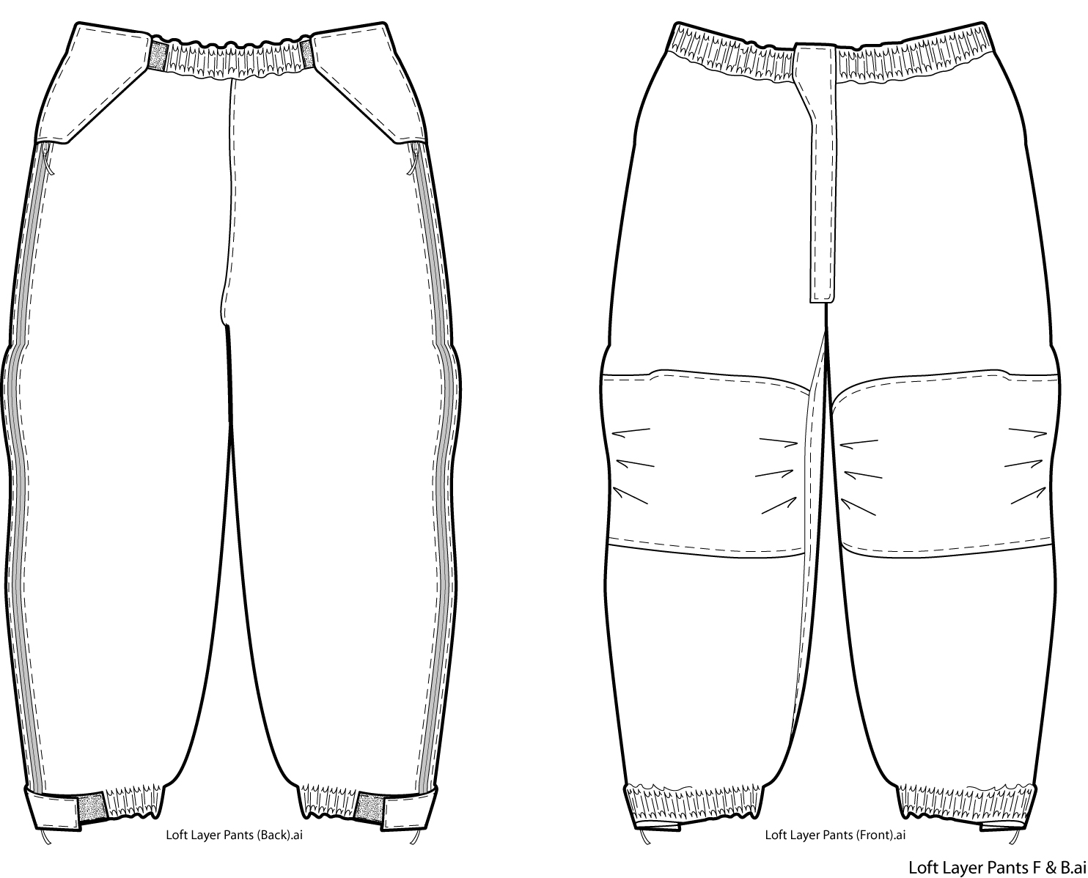
Figure 1
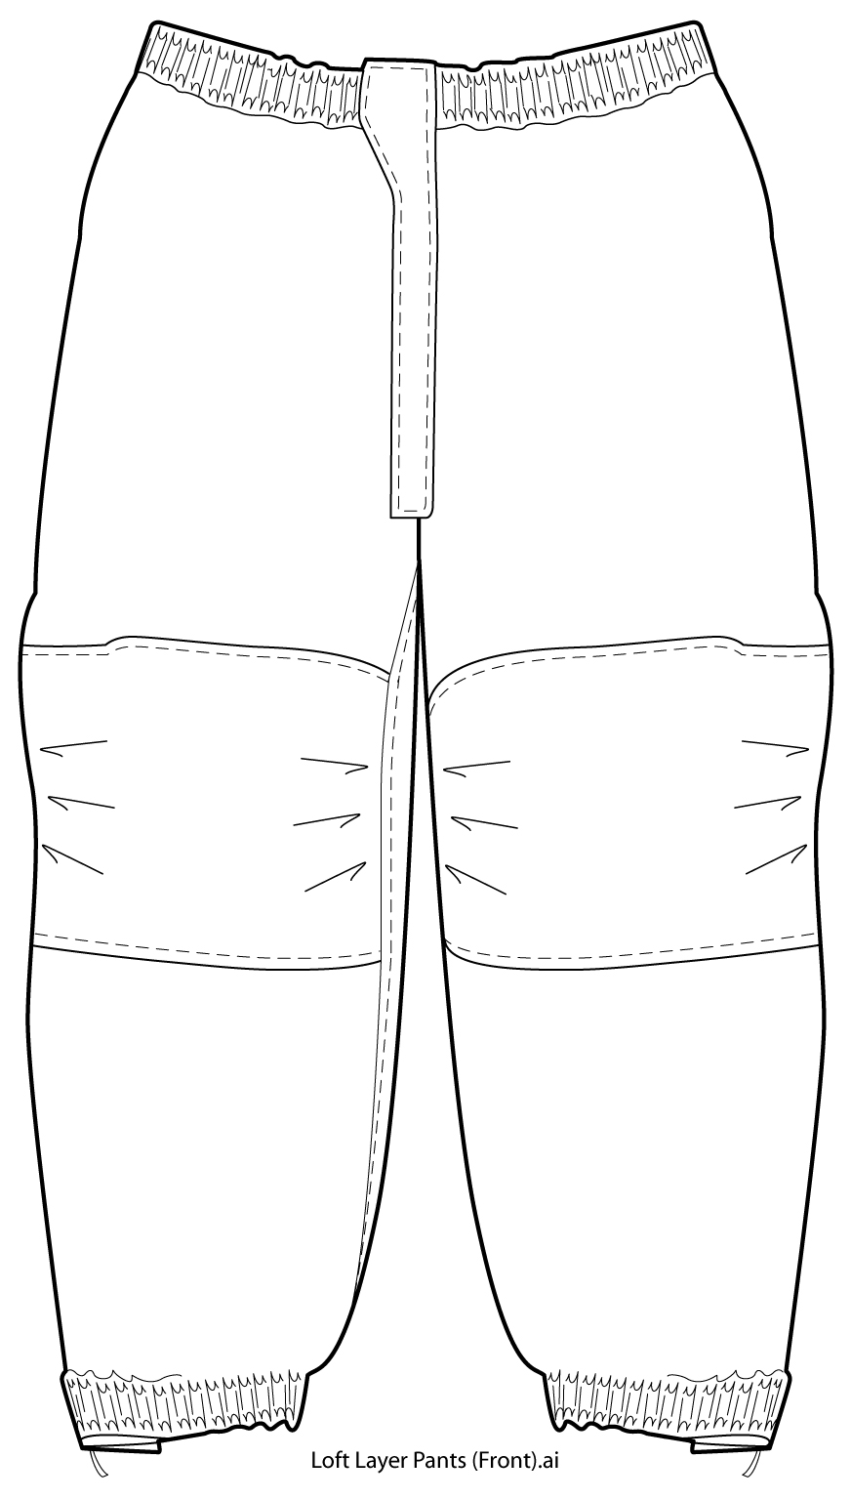
Figure 2
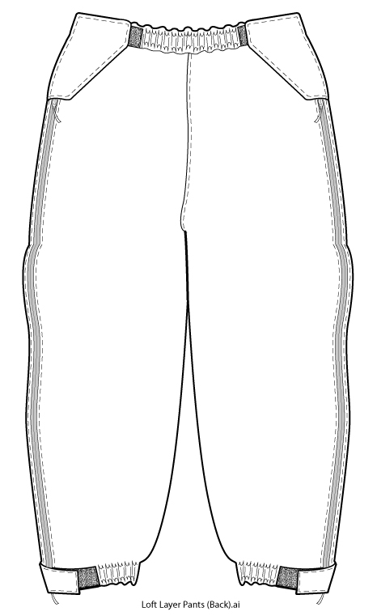
Figure 3

